LabGloves is comprised of analog signal processing circuits that convert every reading into 5V logic level signals for pins on the Atmega 1284p MCU. The MCU then calculates readings and displays them on our LCD display, which is also mounted on the glove. The user can also change reading modes with a capacitive touch button, as indicated by the user interface displayed on the screen.
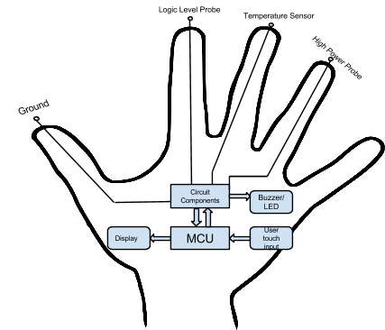
Figure 1: High-Level Design Block Diagram

Rationale and Inspiration
Our goal while brainstorming this project was to create something that could be useful to many people in every-day applications. We finally arrived on the idea of LabGloves based on the observation that people often find tasks more convenient when everything they need is at their fingertips. This allows people to avoid carrying tools around, and makes it so they can use their own hands to manipulate their work in an intuitive way. With this in mind, we were sitting in ECE 4760 lab (directed by Dr. Bruce Land at Cornell University) using a probe when we finally found our inspiration to design a wearable multimeter.

We found that this was a project unique from work done by previous groups in ECE 4760, and after a search of the US Patents and Trademark Office website it appears this is something that has yet to be attempted elsewhere as well. Particularly, we found that voltmeters, frequency measurements, and similar meters have been developed on microcontrollers—such as the PIC variant, or on the Atmega 644 in previous ECE 4760 labs—but that fully functional, autoranging multimeters seem only to exist as commercially developed products, such as the one pictured in Figure2:
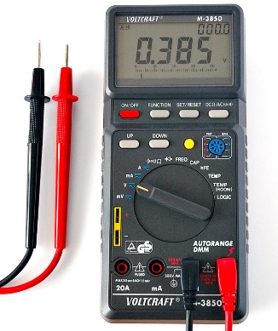
Figure2: Commercial Multimeter

Naturally, our goal was to design and build an autoranging multimeter with as many measurement modes as possible given a month long timespan for development. The outcome was a wearable device that can perform Voltage, Temperature, Resistance, Capacitance, and Frequency readings (and subsequently Pulse Width and Duty Cycle measurements), and that can perform connectivity, diode, and transistor testing. This is significantly more functionality than past projects and labs from ECE 4760 or found in online searches. Moreover, because we successfully implemented autoranging beyond that done in the past in 4760, we feel that our project is very successful considering our initial goals.

Background Mathematics
As our digital multimeter (and all digital multimeters) actually only measure voltage, we had to use several algorithms to extrapolate all readings from voltages. Refer to Table I below.
Resistance | $$R_{test} =\frac{R}{\left(\frac{Vcc}{Vin} - 1\right)}$$
Capacitance | $$v\left(t\right)=Vcc*\left(1-exp\left(-\frac{t}{τ}\right)\right), τ=\left(R2\right)*C,$$
Frequency | $f=\frac{1}{T},$ T is determined by the timer1 capturing positive edge from source.
Pulse Width | Determined by capturing negative edge of signal from source.
Duty Cycle | $$Duty Cycle=\frac{Pulse Width}{T}$$
Temperature | $$T℃\sim \frac{Vin}{0.016}$$
Table I Equations Used
Logical Structure:
Lab gloves boots to a splash screen where the user can then select a mode. Once a mode is chosen our MCU changes port configurations to select peripheral circuitry that is appropriate for each mode and makes the applicable calculations for measurements, such as what resistances to select on a MUX for proper ranging.

Hardware Tradeoffs:
We decided to use an analog DEMUX to autorange resistance and capacitance for this project, and our voltage input runs through it, so we will have to use relays of some sort if we want to work in higher powered systems in the future because the CD4051BCN 8:1 analog DEMUX has voltage limits of around 15V and current limits of up to 1 amp. For this reason, we decided to have a separate high voltage sensing mode in which we send voltages higher than 5V through a 1/10 divider to a different ADC pin on the MCU than for LV modes.

Existing Products
Much like our project, modern digital multimeters actually only measure voltage. Current is measured as the voltage across a shunt and resistance is measured by measuring the voltage across the resistance with a constant current flowing through the resistance.

How a digital voltmeter works internally depends on the manufacturer. The early meters used a dual-slope integrating digital conversion technique that was reasonably accurate and good at suppressing noise. It is slow however, about ten readings per second or less. With modern digital signal processing, over-sampling 1-bit delta-sigma converters can perform with better accuracy, and usually more rapidly.

A side benefit to digital signal processing is the ability to measure time intervals, and hence frequency of an AC signal, or the time to charge a capacitor with a constant current to a specific voltage, and hence measure capacitance. Virtually all digital meters, and some analog meters, feature a "beeper" to allow continuity (low resistance, open or closed circuit) measurements without viewing the meter. Some "multimeters" now even include low-bandwidth waveform display and recording functions, much like an oscilloscope.

LabGloves has the advantage of timers on its MCU so it can measure all of these things, and its placement on the user’s fingertips allows for operation that is unique from any multimeter on the market. With continued improvement in read outs, we are confident that our project has great potential to make an impact to multimeter users everywhere.

