Mouse Nose sensor:

Introduction:
A lab in neurobiology is interested in an experiment where mice are being trained to distinguish between different smells. In this experiment, there are 9 dishes of sand in an environment, and each has a different smell. Certain scented sands have Froot Loops buried at the bottom of the dish, and others do not. The experimenters would like to be able to tell when the mice have connected the specific scents to the reward (or no reward). They can tell this when the mice only dig in the specific dishes that have those scents. To do so, we want to create a non-invasive, safe way to determine which dish the mouse is digging in. Previously, there had been the thought of putting a sensor inside the environment; accessible to the mouse, but since the mice like to chew on wires, so this idea was discarded. Then, we had heard about an E-field sensor chip ( http://www.freescale.com/files/analog/doc/data_sheet/MC33794.pdf ) recently created by Motorola, and hoped to use it for this project. The chip had been used in situations such as a keypad that requires no mechanical buttons. It detects variations in the E-field around the electrode (thus, it does not require direct contact with the mouse). So, we planned to put electrodes around the cage, and then record their outputs, which could be linked to different mouse behavior (running, resting, standing, digging, etc).

Specifications:
In this project, there should not be anything invasive to the mouse or anything that will potentially shock the mouse (especially nothing that could electrocute the mouse). The data should be communicated to a computer, where it can be collected, stored, and processed.

The hardware:
The PCB:
The PC board was created using ExpressPCB. The section of the board dealing with the ATMEL Mega32 microcontroller was adapted from a PCB layout previously done by Professor Bruce Land.

The location of the Motorola E-field chip is in the upper left of the figure below. To the left of the chip, the electrodes are connected to the board via a header whose pins are spaced 0.1” apart. To protect the integrity of the signals sent to this header, there is a shield on the bottom side of the PCB. As can also be seen in the figure, the majority of the pins of the chip are unused. The only ones that were needed for this project were Ground, Vcc, Vpower, and some of the control pins. The useful control pins were the ones that reset the device, control which electrodes are active, and enable the shield. The only output from this chip is “Level,” which is the analog signal proportional to the E-field near the active electrode. This is sent to the microcontroller for processing.

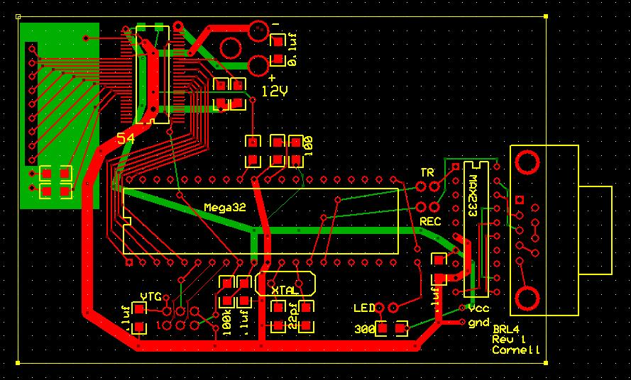
PCB layout

The Motorola E-field sensor:
Motorola's e-field imaging chip, the MC33794, was used for collecting data about the proximity of the mouse to the electrode, which is to be placed at the bottom of a glass dish, filled with sand. We saw previous projects (such as a non-mechanical keypad) using this chip, and this is where we got our idea to use it for the mice. . We chose this chip because of its ability to collect data about the proximity of the mouse, without direct contact with the mouse, and also without leaving any wires exposed for the mouse to chew on.

The ATMEL Mega32:
This microcontroller was chosen due to its ability to quickly convert between analog and digital signals. In addition to this, familiarity also led us to choose this chip. It had been previously used for analog to digital conversion in a course taught by Professor Land. For this E-field experiment, we needed the chip to take in data from the Motorola chip, convert it to a digital signal, and then send the data on to the PC. This need is basically the same as the need in the thermometer experiment, so we chose to use the same chip. After the data has been converted, we need to send it to the computer, and to do so we used the MAX233ACPP dual RS232 interface.

The code:
We wrote C code to control the Mega32 microcontroller. Every 10 ms, a measurement is taken of the E-field around the electrode. This is accomplished using a 16 MHz crystal, and setting the code to take an interrupt every 1ms, and then, once every 10 interrupts, a measurement is taken. The measurement is a 10-bit number, which is then transmitted serially to the computer. The code is in the appendix of this report.

Gus Lott helped me to write the MATLAB code used for collecting the data. It takes in the ASCII data from the serial port on the PC, converts it to the appropriate numerical data, and plots it. Then, we modified it to smooth out the noise in the data. The code is in the appendix of this report.

An example of output from this MATLAB code, where the mouse “nose” is dipped into the “dish” (at approximately time units 1050-1200), is shown below:

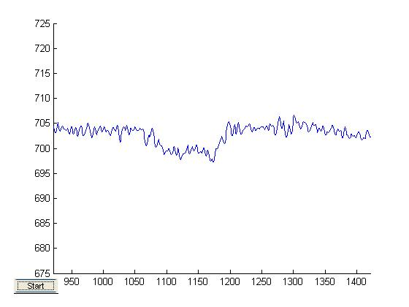
User interface for MATLAB program (one “dip” of the “nose” shown)
The setup:
The Mega32, MAX233ACPP, MC33794, and various capacitors/resistors were soldered to the PCB. This can be seen in the figure below, to the left. Then, a model of the mouse's environment was created out of a cracker box and tin foil. A circle of diameter 55mm was cut out of the box, and dropped down 10mm from the plane surface of the box. This circle was covered in foil, and it is our electrode. The rest of the box's top was also covered in foil, and is our grounded plane. This can be seen in the figure below, to the right.

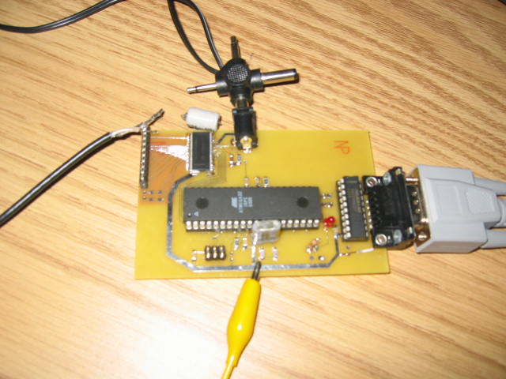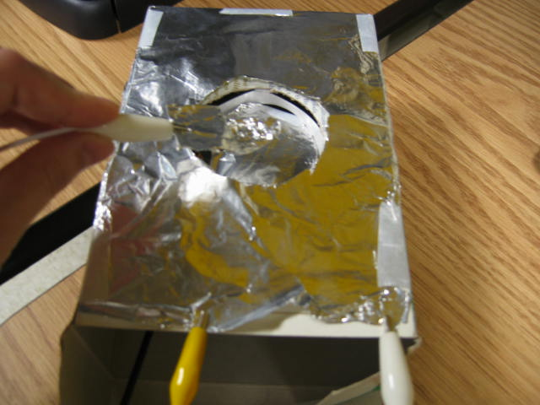
PCB Model of “mouse nose” and its environment

The photo of the PCB shows the power supply connection at the top, the serial connection to the PC at the right, the ground connection to the model at the bottom, and the coaxial cable that connects the electrode to the circuit is at the left. The coaxial cable is shielded, to prevent noise from harming the integrity of our signal. An illustration of the connection between the PCB and the electrode is shown below:

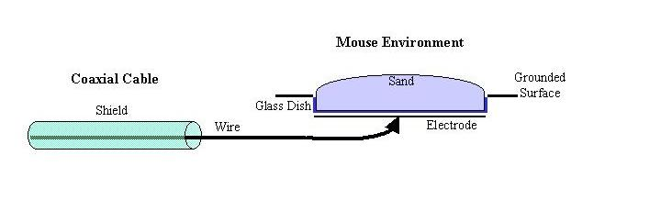
Illustration of Coaxial Cable connection to electrode

Part II:
In the second semester of working on this project, we started working on improving the data collection. We made the MATLAB code try to account for the drift of the data (due to the heating up of the sensor chip as it was used for longer periods of time). However, we found out that the lab wanted a different interface for the input and output from the board. They decided that measuring the raw output voltages from the sensors would be more flexible. The role of the microcontroller is to synchronize input and output multiplexors so that the 9 input voltages (measured sequentially from the capacitance channels) would appear as steady voltages at the output. We modified the board to have a 20-pin ribbon cable output and a 20-pin input (although the input will not be a ribbon cable, since the leads have to be shielded).
The new PCB layout is below:

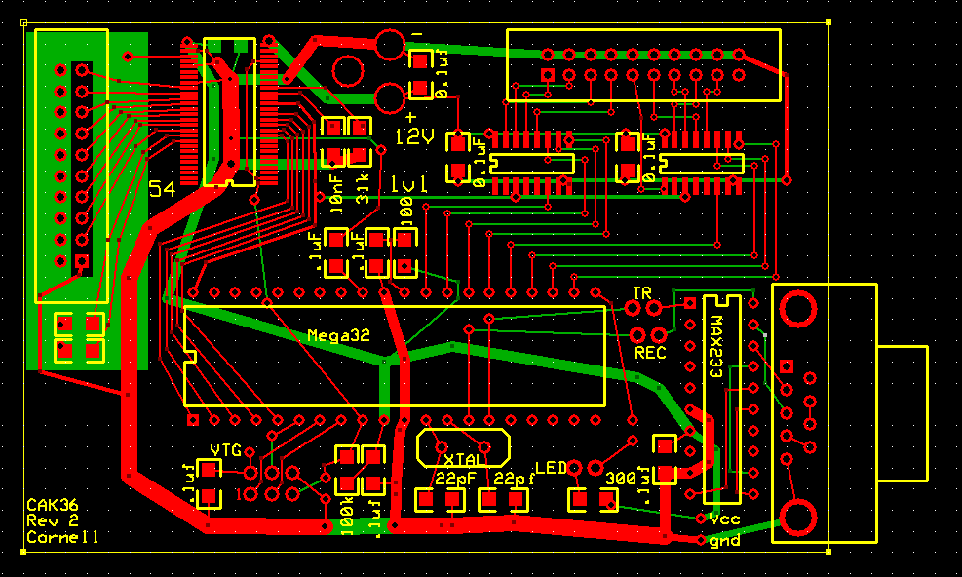
Board with S&H chips

The input is now set up for a 20-pin ribbon header, which is in the upper left, with the left-hand pins connected to the shield, and the right hand pins connected to the electrodes, and then pin #1 (bottom right) is grounded, as requested by the lab sponsoring this project. In the upper right hand corner, there is another 20-pin ribbon header, for output. The upper row of pins is grounded, and the lower pins are connected to two sample & hold chips (directly below the header). Since we needed 9 channels, we used two 8 channel sample & hold devices. For ease of wiring, we used 4 outputs from one chip and 5 from the other, and left the rest floating. These chips are Analog Devices part number SMP08.
Here is a photo of the finished PCB and one channel hooked up to an electrode:

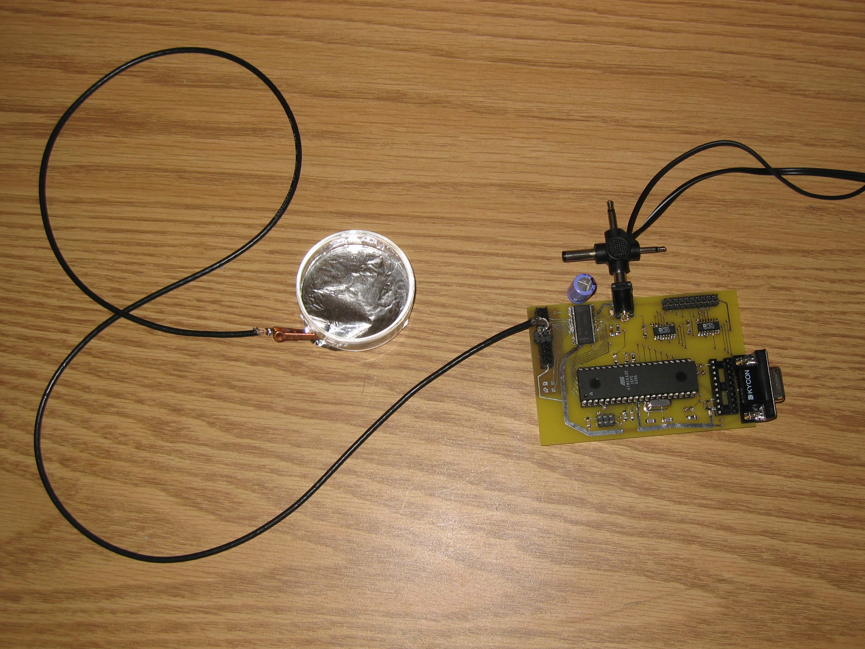
New PCB with electrode
And the schematic diagram of this new PCB layout is below:

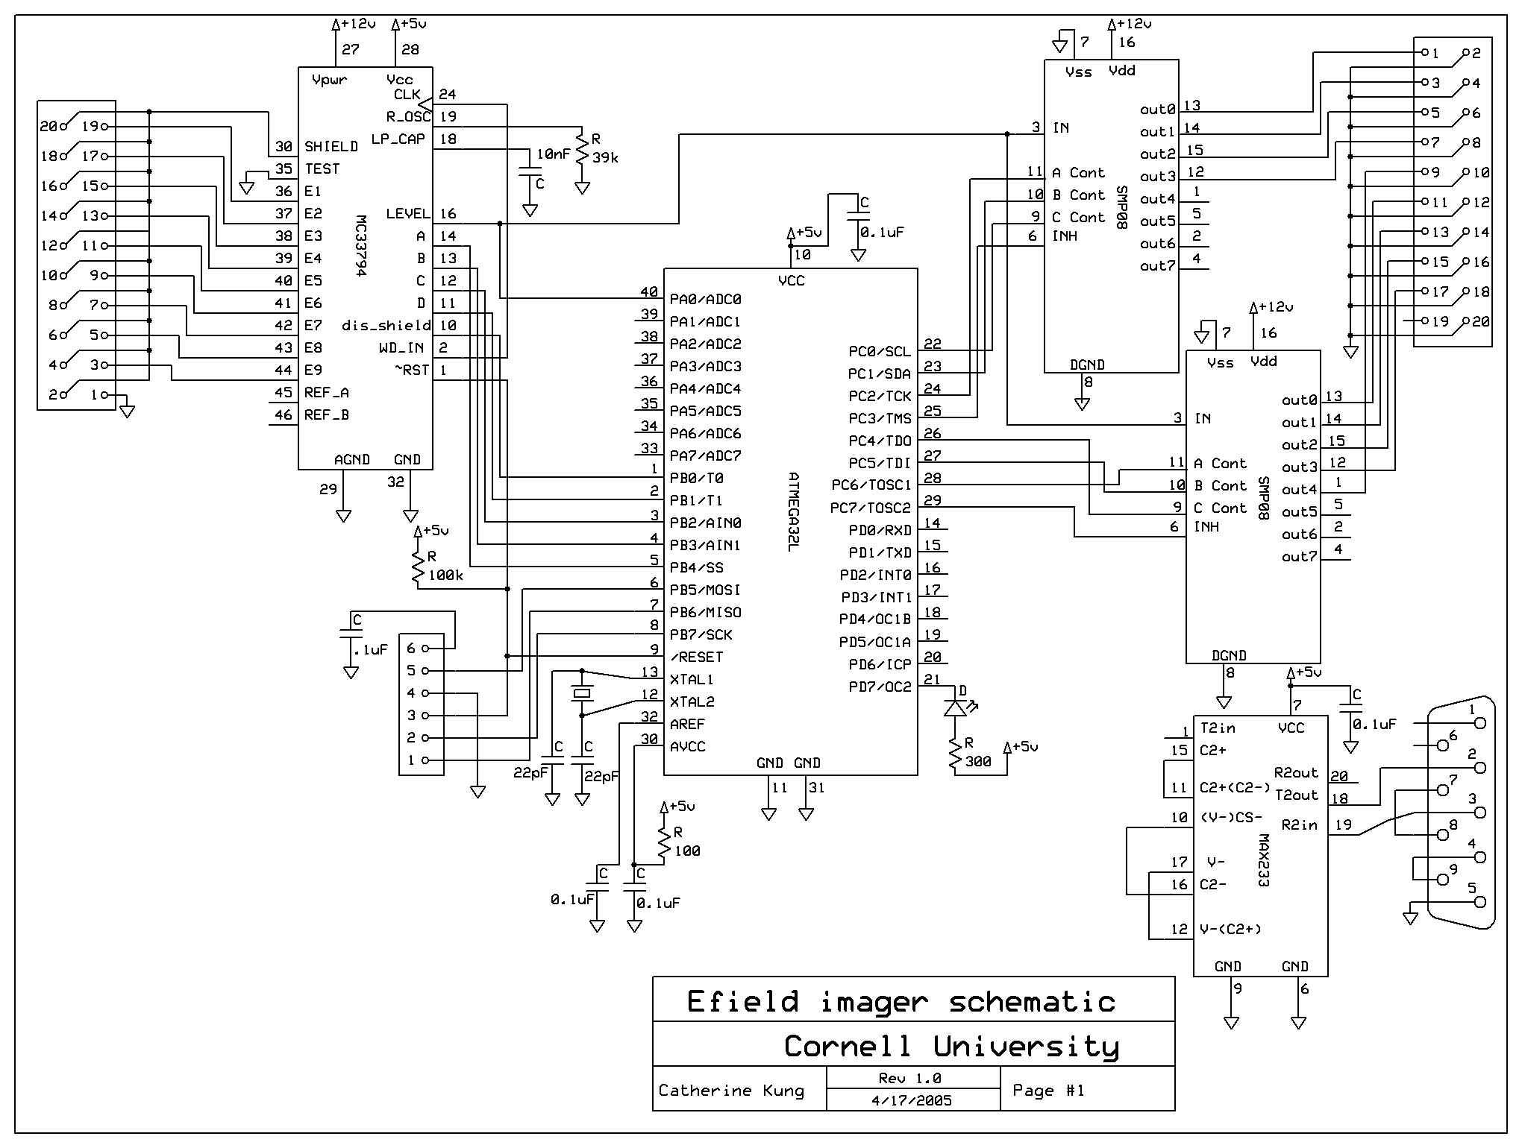
New Schematic

In addition to this, we created a more durable model. We used a plastic mouse cage, along with an aluminum plate, and actual glass dishes that have been used with the mice. This is shown in the photo below:

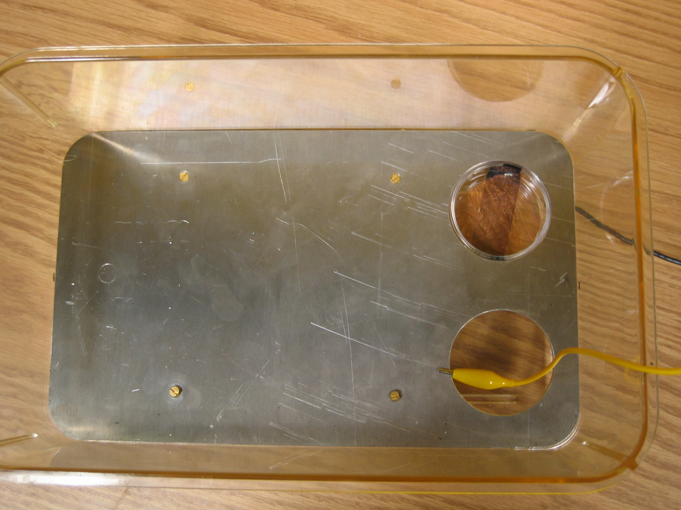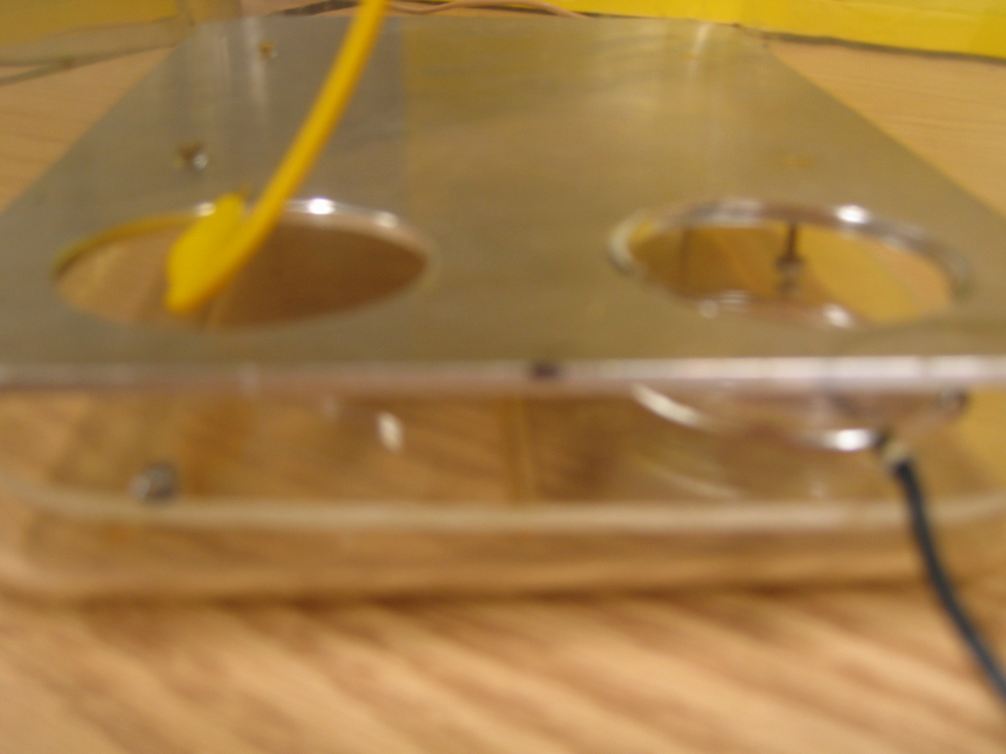
New Mouse “Cage” New Mouse “Cage” side view

Conclusions:
This project now works with 9 different electrodes. The board sequentially samples each electrode and then outputs 9 different channels of voltages proportional to the readings from each electrode. We tested each channel singly, and the next steps of this project would be to test them all together simultaneously, and also to test it with a live mouse, rather than a human hand.
Appendix:
C Code:
#include <Mega32.h>
#include <stdio.h>
#include <stdlib.h>
#include <math.h>
#include <delay.h>

#define begin {
#define end }
#define cycledelay 5

unsigned int time1, Ain;
char outletter, cycler;

/*interrupt[TIM0_COMP] void timer0_compare(void)
begin
if (time1>0) --time1;
end

interrupt[USART_RXC] void uart_rec(void)
begin
UDR = voltage; // print out analog signal (realtime)
end */

/*interrupt [ADC_INT] void readADCH(void)
begin
Ain = ADCL;
Ain = Ain + 256*(int)ADCH;
end */

void initialize(void)
begin
DDRA=0x00; // A is an input (takes in the "level" signal)
DDRB=0x1f; // B.0-4 is output (controls the sensor), B.5-7 is input (programming)
DDRD=0xff; // D is an output (controls the LED)
DDRC=0xff; // C is an output (controls the s&h)

PORTB=0x10; // set B to activate pin1's electrode

delay_ms(250);

//time1 = 10;
cycler=0;

//set up A-to-D converter
/*ADMUX = 0b01000000;
ADCSR = 0b11001110;
MCUCR = 0b10010000;

TIMSK = 2; // turn on timer 0 compare match isr
OCR0 = 250; // set compare to 250 time ticks
TCCR0 = 0b00001011; // prescale to 64, and set to clear on match

UCSRB = 0b00011000 ; //hex 0x18
UBRRL = 103 ; //using a 16 MHz crystal (9600 baud)
//putsf("Begin\n\r");

#asm
sei
#endasm */
end

void main(void)
begin

initialize();

while(1)
begin

if (cycler==0)
begin
PORTB=0x10; //turn on src ch 1
delay_ms(cycledelay);
PORTC=0x08; //turn on left s&h ch 0
cycler++;
delay_ms(cycledelay);
PORTC=0x88; //inhibit/turnoff s&h chips
end
else if (cycler==1)
begin
PORTB=0x08; //turn on src ch 2
delay_ms(cycledelay);
PORTC=0x48; //turn on left s&h ch 1
cycler++;
delay_ms(cycledelay);
PORTC=0x88; //turn off s&h chips
end

else if (cycler==2)
begin
PORTB=0x18; //turn on src ch 3
delay_ms(cycledelay);
PORTC=0x28; //turn on left s&h ch 2
cycler++;
delay_ms(cycledelay);
PORTC=0x88; //turn off s&h chips
end
else if (cycler==3)
begin
PORTB=0x04; //turn on src ch 4
delay_ms(cycledelay);
PORTC=0x68; //turn on left s&h ch 3
cycler++;
delay_ms(cycledelay);
PORTC=0x88; //turn off s&h chips
end
else if (cycler==4)
begin
PORTB=0x14; //turn on src ch 5
delay_ms(cycledelay);
PORTC=0x81; //turn on right s&h ch 4
cycler++;
delay_ms(cycledelay);
PORTC=0x88; //turn off s&h chips
end
else if (cycler==5)
begin
PORTB=0x0C; //turn on src ch 6
delay_ms(cycledelay);
PORTC=0x80; //turn on right s&h ch 0
cycler++;
delay_ms(cycledelay);
PORTC=0x88; //turn off s&h chips
end
else if (cycler==6)
begin
PORTB=0x1C; //turn on src ch 7
delay_ms(cycledelay);
PORTC=0x84; //turn on right s&h ch 1
cycler++;
delay_ms(cycledelay);
PORTC=0x88; //turn off s&h chips
end
else if (cycler==7)
begin
PORTB=0x02; //turn on src ch 8
delay_ms(cycledelay);
PORTC=0x82; //turn on right s&h ch 2
cycler++;
delay_ms(cycledelay);
PORTC=0x88; //turn off s&h chips
end
else if (cycler==8)
begin
PORTB=0x12; //turn on src ch 9
delay_ms(cycledelay);
PORTC=0x86; //turn on left s&h ch 3
cycler=0;
delay_ms(cycledelay);
PORTC=0x88; //turn off s&h chips
end
else
begin
PORTB=0x00; //turn off src (intrnl src now)
PORTC=0x88; //turn off s&h chips
cycler=0;
end

/*if (time1==0)
begin
time1 = 10;
printf("%u\r\n\r\n", Ain); //formatted for hyperterminal
end */
end
end

MATLAB Code:
function serialcomm5(varargin)

switch nargin
case 0
close all;
s = instrfind('type', 'serial');
if length(s) ~= 0
fclose(s);
delete(s);
clear s;
end
makegui
case 1
feval(varargin{1});
end

%------------------------
function makegui

gui.s = serial('COM1', 'BaudRate', 9600);
gui.fig=figure('renderer','opengl','tag','scfig');
gui.ln=line([NaN],[NaN]);

gui.go=uicontrol('style','toggle','string','Start','callback','serialcomm5(''gostop'')');
set(gui.fig,'userdata',gui)

%------------------------
function gostop
gui=get(findobj('tag','scfig'),'userdata');

switch get(gcbo,'value')
case 0
set(gui.go,'string','Start')
case 1
set(gui.go,'string','Stop')
fopen(gui.s)
[b,a]=butter(4,.3);
yydata=[];
while get(gui.go,'value')==1
pause(.1)
if ~ishandle(gui.ln)
break
end
if gui.s.bytesavailable<5
drawnow
continue
end
temp=str2num(char(fread(gui.s,gui.s.bytesavailable))')';
yydata=[yydata,temp];
ydata=filter(b,a,yydata);
xdata=1:length(ydata);
set(gui.ln,'ydata',ydata,'xdata',xdata)
set(get(gui.ln,'parent'),'xlim',[length(ydata)-500 length(ydata)])
set(gca, 'ylim', [675 725])
drawnow
end
fclose(gui.s)
end

