CURIE Program Summer 2011
Project 1

Introduction:

While sleep disorders may be discounted by some as not particularly important, they in fact represent a very serious health issue. Sleep disorders encompass a myriad of problems including sleep apnea, insomnia, narcolepsy, recurring nightmares, circadian rhythm issues, among others. Sleep disorders are particularly insidious as they strike a person while unconscious. The person is unaware of any problem. A person with a sleep disorder like sleep apnea will wake feeling tired, irritable, and may have problems concentrating or recalling information. Performance on the job or at school may suffer. Personal relationships may sour owing to sleep deprivation-induced irritability. Also, there are physiological problems associated with sleep disorders; for instance, it is known that sleep apnea can lead to elevated blood pressure. Treatment of sleep disorders is thus getting at the underlying basis of many debilitating conditions ― both psychological and physiological ― and can markedly improve a person’s quality of life.
Not so long ago, sleep was regarded as a non-productive state of little consequence and disorders of sleep as nothing more than the manifestations of an indolent mind. However, people are now more appreciative of the importance of slumber and are going to great lengths in the pursuit of fulfilling sleep.

Obstructive sleep apnea:

Obstructive sleep apnea (OSA) is the most common type of sleep-disordered breathing. It is characterized by unusual pauses or cessations in breathing during sleep. It is caused by a physical obstruction of the airway. The airway is composed of collapsible walls of soft tissue. Muscles relax during sleep and so the upper airway can become blocked during sleep, especially if there is an abundance of soft adipose (fat) tissue surrounding the airway or if muscle tone is reduced. OSA is common in overweight individuals. Patient family members ― children and spouses ― are often aware of OSA, being awakened or otherwise disturbed by snoring, cessation of breathing, and gasping for air. Family members are often able to provide a description of symptoms that assist doctors in the diagnosis of probable OSA. Official diagnosis is provided by a polysomnogram or sleep study in which the patient spends a night at a sleep center and is monitored throughout the course of the night by technicians. Patients are monitored on camera and cessations in breathing can be directly observed. Oximeters may be attached to the patient to detect drops in blood oxygen levels caused by breathing arrests.

Current Treatment Options for Obstructive Sleep Apnea:

The most common treatment is an assisted breathing device called a continuous positive airway pressure (CPAP) mask, designed to keep the upper airway open during sleep. A seal is maintained by inserting tubes into the nose and securing the mask with straps around the patient’s head. In appearance, a CPAP mask resembles a gas mask. Sometimes surgery is undertaken to widen the upper airway in cases of severe OSA.

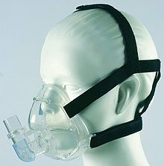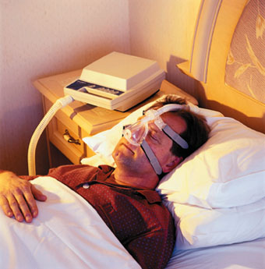

Shortcomings of Existing Treatment Options:

CPAP devices are costly and cumbersome. Many people fail to acclimate to the use of CPAP, often citing comfort issues as a reason for abandoning the device. Some people are claustrophobic and are uncomfortable wearing a mask. People also may not adjust to having to breathe out against positive pressure resistance. Surgery of course represents a highly invasive option for addressing OSA and carries with it the risks associated with any operation in which a patient is sedated with general anesthesia.

Proposed Alternative:

The alternative treatment for obstructive sleep apnea consists of an electromechanical physical therapy device designed to increase the strength of a person’s tongue, or genioglossus. The patient will train with this device while awake. The hypothesis is that a stronger tongue will serve to hold open a person’s upper airway (increase upper airway patency) while asleep. By increasing muscle tone of the upper airway, the number of breathing arrests per night should be reduced. Ideally, patients will exhibit both quantitative (fewer breathing pauses per night) and qualitative (self-reported descriptions of reduced fatigue) after training with the device.

Importance of Feedback:

To be utilized as a medical training device, it is vital that the device communicate with the user. Simply having a patient press his tongue against a force sensor would make for a very poorly designed medical device. An analogy would be a person attempting to lose weight on a diet but never having access to a scale. Without knowing whether the diet is working, very few people would have the incentive to continue with the regimen. If the device simply recorded the force values for later analysis by a clinician, the patient would not know until the end of the study if he was getting stronger. By providing feedback to the patient, particularly in real time, a device could make training much more effective. Whether by some visual indication or an auditory cue, the user must know if they are succeeding in exerting more force.

Feedback Introduction:

Humans perceive the world as a continuum. Our eyes and ears are analog sensors. Our eyes can perceive very low levels of light, very bright light sources, and everything in between. Our ears can perceive sound waves with a frequency as low as around 20Hz and a frequency as high as 20kHz and every frequency in between. Computers are digital devices. They can make sense of digital data, data that is in discrete form. Computers are great at opening or closing a switch, at turning a light on or off. In order to process data that appears as a complete, continuous range, that analog data must be converted into a form that a computer can make sense of and manipulate. The analog data must be converted into digital data. This is accomplished with an analog-to-digital converter (A/D converter).

Components You Will Use in This Lab:

Resistor:
A resistor does just what its name suggests: it resists the flow of current. A resistor is one of the simplest electronic components, yet also one of the most important. Resistors are used to limit current to safe and acceptable levels or to ensure that a desired current flows through another component. Also, resistors are used to reduce voltages. Resistors may be fixed (preset, non-adjustable) or they may be adjustable. Adjustable resistors are called potentiometers. The resistance of a potentiometer can be varied from zero to a maximum value. Potentiometers can be either analog or digital. Analog potentiometers are manually adjusted by turning a knob. Digital potentiometers are adjusted automatically by a computer. Resistors can also serve as sensors. Some resistors are designed so that their resistance changes with temperature (thermistors) or with light (photoresistors).

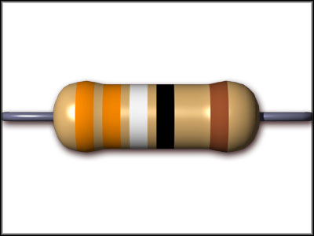

Piezeoelectric buzzer:
A piezeoelectric buzzer is a speaker that relies on the piezoelectric effect for its operation. The piezeoelectric effect is the phenomenon certain materials exhibit: when a mechanical force is applied and the material deforms, an electric potential is produced and conversely, when a voltage is applied to them, they deform. If a time-varying signal is applied, the material will deform in a rhythmic manner. Attached to the piezeoelectric crystal is a membrane, which moves the air and produces sound waves.

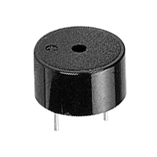

LED:
A light emitting diode (LED) is a semiconductor designed to emit light. Whereas incandescent bulbs emit a wide spread of wavelengths that taken together appear as white light, LEDs emit light at a single wavelength, or color. Some are red, others yellow, infrared (IR), or ultraviolet (UV). LEDs have several advantages over conventional incandescent bulbs. First, they are much more energy-efficient than incandescent bulbs, which give off much of their energy as non-useful heat. Second, LEDs can be turned on and off very quickly, whereas incandescent bulbs have a much slower response time. Incandescent bulbs work by heating a filament to a very high temperature by passing a current through it. Consequently, when the light is turned off, the filament is still at a high temperature. That’s why a light bulb is still hot to the touch after turning off the light. Just like incandescent lights, LEDs can be dim or bright, depending on the amount of current flowing through them. The more current, the more light is emitted. Too much current, however, can be harmful to the LED and can even destroy it. Excessive current is prevented from flowing through the LED by putting a resistor in series with the LED. In contrast to incandescent bulbs, LEDs have a polarity convention that needs to be observed to ensure proper operation. The cathode of an LED needs to be connected to ground or to the negative terminal of a power source while the anode needs to be connected to a positive voltage.

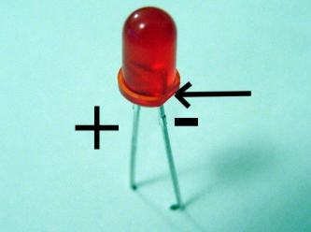

Analog/Digital Converter:
An analog-to-digital converter (ADC) is an integrated circuit that converts a continuous signal into a discretized signal understandable by computers. The quality of an ADC is determined by how many bits with which it approximates the analog signal. A 1-bit ADC can represent data as either on or off. Nothing in between. Only two states are possible just like in a black or white image. In a purely monochrome image, each pixel is either black or white. There are no gray pixels. A 4-bit ADC can provide 16 (2⁴) graduations: white, black, and 14 shades of gray. A 12-bit ADC can approximate an analog signal with 4096 (2¹²) degrees. A 12-bit ADC is said to possess a much higher resolution than an 8-bit ADC. Specifically, a 12-bit ADC has 16 times the resolution as an 8-bit ADC (2¹²/2⁸ = 2⁴). Resolution is the ability to differentiate or distinguish between two closely spaced objects or two signals of nearly the same value. A 12-bit ADC may be able to differentiate between 4.25V and 4.24V, but an 8-bit ADC may not.

Microcontroller:
A microcontroller is a miniature computer. It has a processor and memory. Like a computer, a microcontroller is designed to interact with other devices. It can receive input and send output, just like how a computer can receive input from a keyboard or a mouse and send output to a printer or speakers. Microcontrollers are used in specific applications, with one single purpose. Microcontrollers are used in embedded systems, everything from washing machines to microwave ovens to medical devices. Computers are much more general and used for many different purposes. Microcontrollers are embedded within appliances and devices. A microcontroller provides much greater flexibility and control over electronics than is possible through the use of electronic hardware alone. By programming a microcontroller to read data from sensors and to control actuators and output devices, a much more capable and reliable device can be created.

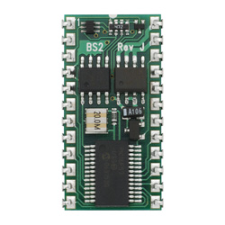

You are tasked with designing and implementing four different feedback displays for the proposed alternative treatment for obstructive sleep apnea and assessing which one is most effective at communicating the force a patient is exerting back to the patient.

The four feedback displays are:

- Auditory:
  - Using a piezo buzzer, build a device that will relate force by changing pitch. When the patient exerts more force, the buzzer should increase in frequency (or pitch), and when the patient exerts less force, the buzzer should decrease in frequency (or pitch).
- Visual:
  - Use an LED bargraph (an array of 10 LED segments in one package) to display the current force to the patient. As the patient exerts more force, more lights should come on, and when the patient exerts less force, fewer lights should be on.
- Visual:
  - Use the force the patient is exerting to control the brightness of an LED. As the patient exerts more force, the light should grow brighter, and when the person exerts less force, the light should grow dimmer. Hint: You can achieve this using either a software-based or hardware-based approach. For the software approach, you will need to use pulse width modulation (PWM). PWM means very quickly changing from a high to low state and precisely controlling the amount of time spent at a high state and at a low state. Or you can use a digital potentiometer to control a single LED. Attempt both.
- Visual:
  - Make an LED change color as the force the patient exerts changes. Use a tricolor LED to represent the force the patient is exerting. A recommended intuitive color scheme would be to use the order of colors in the visible spectrum i.e. red would correspond to a small force and blue would correspond to a large force. The LED you will be using is a tricolor LED. It has three LEDs in one housing: red, green, and blue. How will you make it produce the other colors of the spectrum: orange, yellow, and violet? Will your LED change color abruptly, switching from red to orange? Or will it change color gradually, from red to reddish orange to orange?

Tips/Hints:
Tackle this project in steps, not all at once. Progress from one part to another in a logical manner. For example, first succeed in connecting the force sensor to the microcontroller and confirming that you are able to read force values from the sensor. You will be using the force sensor and the ADC in all four of your feedback systems. So get that part finished first. What is the lowest force reading (when patient is not pressing)? Is it exactly zero? If not, how will you deal with it? What is the highest force reading (corresponding to the patient exerting a very large force)? What is the range of the force data to display? Next, learn how to control the piezo buzzer and visual indicators. Next, use the input from the force sensor to control the indicators. How do you want to relate the input force to the auditory or visual cues? Should there be a linear relationship? An exponential relationship? A continuous relationship, meaning for every unique force reading, a unique output results? A discrete relationship, meaning that if the input force falls within a certain range or bracket, the same output results?

References:

I. Mortimore et. al., “Tongue protrusion force and fatiguability in male and female subjects.” European Respiratory Journal. 1999; 14: 191-195.
Basic Stamp Syntax and Reference Manual

