

Capability Enhancements for Autonomous Mobile Wireless Sensors

Team 05506
February 13, 2005
Preliminary Design Report

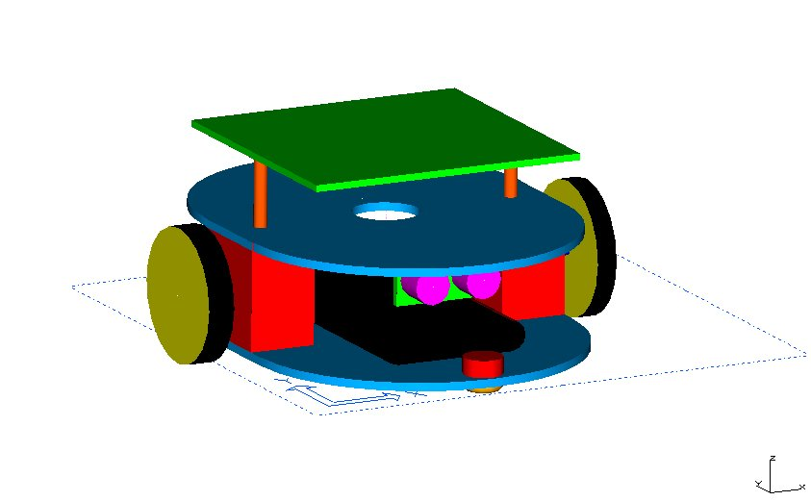
Current Mobile Sensor Platform Prototype

Team Members
Andrew Mullen | Adam Haun
Edgar Martin | Darnelle Haye
Stephen Ortiz | Khoa Nguyen

Department of Computer Engineering
Kate Gleason College of Engineering
Rochester Institute of Technology
76 Lomb Memorial Drive
Rochester, NY 14623-5604
Executive Summary

This preliminary design report summarizes the progress made by the Capability Enhancements for Autonomous Mobile Wireless Sensor Senior Design Team. The goal of this project is to design, fabricate, and test four autonomous sensor platform which will be able to communicate using wireless technology to other identical platforms. Upon completion of the four sensor platforms, an algorithm will be designed and implemented allowing the platforms to reorganize themselves into different formation topologies. This project mimics the use of a group of robots to accomplish a task and work together as a team.
The team used the Engineering Design Planner™ methodology to design the mobile sensor platform. The first five aspects of this process have been successfully completed. The first aspect of the report, recognizing and quantifying the need, discusses the goals, motivation, and background for the project. The second aspect presents an overview of concept development process as well as the concepts generated by the team. The next section presents the feasibility assessment the team conducted for the generated concepts and the recommendations of the team. The fourth aspect presents a detailed description of the goals of the project and the specifications to which the project must adhere. The final aspect, analysis and design, is the bulk of the report. It describes the analyses that have been done to design the sensor platform as well as the progress that has been made so far. The last aspect of this report gives an overview of the current status of the project, describes the plans for future experimentation, and presents a plan for completing the project on schedule and within budget.
Utilizing the Engineering Design Planner™ allowed the team to develop a more efficient design. Through the framework presented, the project was given focus and direction. The generation and analysis of concepts stages were important in allowing the project team to view the final product from a different angle and produce a better product. The team successfully designed and constructed a prototype sensor platform that utilizes all of the expected functionality of the final design. However, the most complex task remains; increasing the efficiency of the platform and development and implementation of an algorithm to allow the robots to create formations.

Table of Contents

 | Executive Summary | 02
 | Table of Contents | 03
 | List of Figures | 06
1 .0 | Recognize and Quantify Need | 07
1 .1 | Mission Statement | 07
1 .2 | Product Description | 07
1 .3 | Scope Limitations | 08
1 .4 | Stakeholders | 08
1 .5 | Top Level Critical Financial Parameters | 08
1 .6 | Financial Analysis | 08
1 .7 | Primary Markets | 09
1 .8 | Secondary Markets | 09
1 .9 | Innovation Opportunities | 09
1 .10 | Background Research | 10
1 .11 | Formal Statement of Work | 11
2 .0 | Concept Development | 12
2 .1 | Delineation of Concepts | 12
2 .2 | Communication System Concept | 13
2 .2 .1 | PC Based Communication | 14
2 .2 .2 | Mica2dot RF Communication | 14
2 .3 | Electronics and Sensor Concept | 15
2 .3 .1 | Infrared Sensors | 16
2 .3 .2 | Ultrasonic Sensors | 17
2 .3 .3 | Compass Sensors | 18
2 .3 .4 | Motor Controllers | 19
2 .3 .5 | PIC Microcontroller | 19
2 .4 | Locomotion Concept | 20
2 .4 .1 | Chassis Concept | 21
2 .4 .1 .1 | Differential Drive | 22
2 .4 .1 .2 | Synchro Drive | 23
2 .4 .1 .3 | Car Type Drive | 23
2 .4 .1 .4 | Skid Steer Drive | 24
2 .4 .2 | Four Wheels | 25
2 .4 .3 | Two Wheels | 25
2 .4 .3 .1 | Caster Pivots | 25
2 .4 .3 .2 | Ball Bearing Pivots | 26
2 .4 .4 | Motors | 26
3 .0 | Feasibility | 28
3 .1 | Communication System Feasibility | 28
3 .1 .1 | PC Based Communication | 28
3 .1 .2 | Mica2dot RF Transceiver | 29
3 .1 .3 | Communication System Conclusions | 29
3 .2 | Electronics and Sensor Feasibility | 30
3 .2 .1 | Infrared Sensors | 30
3 .2 .2 | Ultrasonic Sensors | 30
3 .2 .3 | Compass Sensors | 31
3 .2 .4 | Motor Controllers | 32
3 .2 .5 | Electronics and Sensor Conclusions | 33
3 .3 | Locomotion Feasibility | 34
3 .3 .1 | Pre-Built Chassis | 35
3 .3 .2 | Custom Built Chassis | 36
3 .3 .2 .1 | Motors | 37
3 .3 .3 | Locomotion Conclusions | 37
3 .4 | Feasibility Conclusion | 38
4 .0 | Performance Objectives and Specifications | 39
4 .1 | Mechanical Design Objectives | 39
4 .2 | Electrical Design Objectives | 40
4 .3 | Software Design Objectives | 40
4 .4 | Mechanical Performance Specifications | 41
4 .5 | Electrical Performance Specifications | 42
4 .6 | Software Performance Specifications | 42
4 .7 | Design Practices Used | 43
4 .8 | Safety Issues | 44
5 .0 | Analysis of Problem and Synthesis of Design | 45
5 .1 | Hardware | 45
5 .1 .1 | Mechanical Design | 45
5 .1 .1 .1 | Initial Prototype Designs | 46
5 .1 .1 .2 | Current Prototype Design | 47
5 .1 .1 .3 | Final Design Plans | 48
5 .1 .2 | Electrical Design | 48
5 .1 .2 .1 | Performance Testing | 49
5 .1 .2 .2 | Sensor Performance | 49
5 .1 .2 .3 | Motor Performance | 51
5 .1 .2 .4 | Power Management | 52
5 .1 .2 .5 | Electrical System Schematics | 53
5 .2 | Software | 56
5 .2 .1 | Movement Processes | 56
5 .2 .2 | Sensing Process | 57
5 .2 .3 | Communications | 59
5 .2 .4 | Topology | 60
5 .2 .4 .1 | Procedure for Orientation | 60
5 .2 .4 .2 | Procedure for Creating and Forming Topology | 61
5 .2 .4 .3 | Movement of the Entire Network | 61
5 .3 | Analysis and Design Conclusions | 61
6 .0 | Future Plans | 62
6 .1 | Experimentation | 62
6 .2 | Schedule | 62
6 .3 | Budget | 63
7 0 | Conclusion | 64
Appendices
A .1 | Electrical Pinouts | 65

List of Figures

Page #
12 | Figure 1 – Concept Focus Groups
14 | Figure 2 – PC Based Communication
15 | Figure 3 – Mica2Dot Mote
16 | Figure 4 – Infrared Distance Measurement
17 | Figure 5 - Sharp Infrared Sensor
17 | Figure 6 - Devantech SRF04
18 | Figure 7 - Devantech Compass
19 | Figure 8 - Motor Controller Driver
20 | Figure 9 - PIC Microcontroller
22 | Figure 10 - Differential Drive
25 | Figure 11 - Castor Pivot
26 | Figure 12 - Ball Bearing
27 | Figure 13 - DC Stepper Motor
31 | Figure 14 - Sonar Beam Pattern
35 | Figure 15 - Pre-Built Robots
36 | Figure 16 - Initial Prototype for Weight Testing
47 | Figure 17 - Second Prototype
47 | Figure 18 - Current Prototype Chassis
49 | Figure 19 - System Block Diagram
50 | Figure 20 - Sonar Sensor Measurement Test
53 | Figure 21 - 5-Volt Regulator
54 | Figure 22 - MC3479 Motor Controller Implementation
55 | Figure 23 - Close-up of Single UC3770 Motor Controller Implementation
55 | Figure 24 - Complete UC3770 Motor Controller Interface Implementation
58 | Figure 25 - Time Per Counter Tick
59 | Figure 26 - Mica2Dot Packet Format
63 | Figure 27 – Project Plan for Senior Design II

- Recognize and Quantify the Need

1.1 Mission Statement

The mission of the Capability Enhancements for Autonomous Mobile Wireless Sensor Team multidisciplinary design project group has two main objectives. The first objective is to develop a robust mobile sensor platform, which is small, agile, and power efficient. Once one robot is completed, additional robots will be built to form a robotic sensor network where sensor platforms (robots) may communicate with one another and move from their original deployment locations, so as to form a desired topology that offers full and energy efficient coverage.

1.2 Product Description

Recent technological advances in the design and functionality of wireless devices have made it possible to create wireless motes the size of a quarter which can transmit data to receivers over 100 feet away. Not only are these transmitters small and energy efficient, but they also have significant programming capability in terms of receiving and processing information before passing it on to another mote.
Sensor networks can be made of up tens, hundreds, or even thousands of these small devices. Using an ad hoc transmission protocol, a sensor network may be formed to achieve sensing tasks that were previously infeasible with a single powerful sensor. A key design challenge when creating such a network is to maximize the overall capability and efficiency with the finite resources available on the individual sensors.
The network, which will be constructed for this project, will initially consist of approximately five wireless motes. The protocol in the communication will, however, be able to support significantly more wireless motes. These motes will be connected to individual mobile sensing platforms and will be capable of communication with other platforms effectively. The platforms will be able to move individually or coordinate the movements as a group to create a specified topology dependent on the mission and resources at hand.
The future of this project is to successfully create a group of small mobile robotic sensor platforms that could be deployed as a sensor network to perform a task easily and efficiently.

1.3 Scope Limitations

The sensor platforms will be designed and constructed by a group of 4th and 5th year ME, EE, and CE students. The initial project should last no longer than two academic quarters, yet allow for future teams to enhance or produce more of the mobile platforms. At the conclusion of this project, a functioning group of sensor platforms is desired for demonstration.

1.4 Stakeholders

Stakeholders for this project include the group of ME’s, EE’s, and CE’s working on the project itself. Additional stakeholders include the Kate Gleason College of Engineering and the project sponsor: The Intelligence Community.

1.5 Top Level Critical Financial Parameters

The following describes the critical financial parameters related to this project.
• The preferred size of the sensor platforms is as small as feasibly possible.
• The majority of the components used should be from previous design groups
• The communication scheme preferred is RF.
• The number of sensor platforms constructed must be between three and five.
• The sensors must be robust and not easily destroyed.
• Off the shelf programmable parts must be used due to the time constraint.

1.6 Financial Analysis

A budget of $1000 has been proposed for the robotic sensor network. This budget includes:
• Four robotic platforms.
• Four PIC micro controllers.
• Four transceiver units.
• Four sensing kits
• Distance Sensors
• Direction Sensor
• Rechargeable power supplies
• Motor Controller Interfaces
• Motors

1.7 Primary Markets

The primary market for the robotic sensor network is the military and the project sponsor: The Intelligence Community.

1.8 Secondary Markets

Secondary markets include scientific based corporations such as surveying companies or educational/research groups looking to examine distributed group behavior. The functionality of the robotic network created is limited mainly in the types of sensors that are currently adapted to robot itself.

1.9 Innovation Opportunities

Although algorithms have been created to allow for general topologies to be created by small mobile devices, they are all far too complex to implement on a small PIC microcontroller. However, with the additional information gathered by the sensor package on the robot, we should be able to develop a unique autonomous algorithm allowing the robots to move into formations without the help of a leader or controller.

1.10 Background Research

Simply watching current events show that there is a considerable interest building in the military and other groups in order to build autonomous vehicles. DARPA, the Defense Advanced Research Projects Agency, recently sponsored the DARPA Challenge. The DARPA Challenge is a cross-country race of autonomous vehicles across the California and Nevada desert, with the first place winner receiving a one million dollar prize. Because of the publicity of the DARPA Challenge, there has been a recent boom in research done on autonomous vehicles. Unfortunately most of the algorithms and concepts found are too intricate and expensive to implement on a project of such a small scale. However, in the abstract, concepts such as obstacle avoidance, best path to objective, and object detection can be useful in the design of similar algorithms for this project.
Several government agencies and colleges have begun to focus heavily on research to design autonomous vehicles that can work together as a team or unit to complete a given task. These tasks vary from battlefield scenarios to searching for victims of a natural disaster. Several colleges have sponsored design competitions where students must design and construct a group of small robots that can work together as a team to perform such tasks as playing soccer. These robots can effectively work together as a team, however they often other wireless protocol such as Bluetooth, which do not help us in our implementation.
Very little is known about the primary focus of the project, formation topology, and what is available is often theoretical and possibly simulated at best. Selection of the best formation for the mission at hand often depends heavily upon the specific sensor capabilities of the robot, expected lifetime of the robot, as well as the number of robots present. All of the pre-designed robots (in our price range) are efficient at completing the tasks for which they were designed, however they leave little room for improvement because of limitations on Input/Output, processor power, and robot memory. Therefore, the use of a pre-designed robot is a poor option because the final version would not be robust enough to overcome simple operational barriers or allow future research to be built on top of the existing platforms.
The goal of this project is to design a robot that can handle these complex problems in a simple, efficient, and cost-effective manner. This includes constructing a mobile sensor network that can move into a specified topology, communicate effectively, and be robust enough to handle operational barriers such as the loss of a robot during runtime.

1.11 Formal Statement of Work:

The project team agrees to have the following items completed by the end of the first stage of the design process:
• Facets 1-6 of the design process completed (completed PDR)
• A design for a prototype sensor platform (chassis, electrical layout, software)
• A completed plan for prototype testing (software development & debugging)
• One constructed prototype to be used during software testing

By the end of the second phase of the design process the team agrees to have completed the following items:
• Facets 1-10 of the design process completed (completed CDR)
• A final design for the sensor platforms (chassis, electrical layout, software)
• Four constructed sensor platforms to be used for testing and demonstration
• A complete test data package (to be used in future projects)
• A detailed project website
• A completed technical paper

- Concept Development

2.1 Delineation of Concepts

The first task of the group as a whole was to examine the project and its desired outcomes and break down the project into manageable components in order to work more efficiently on each part. In this way, the team could be further divided into specialist groups. Since the project was a six-member team, three main categories for research and development were selected. These major categories are shown in the second row of Figure 1 – Concept Focus Groups below.
Mobile Wireless Sensor Platform Development
Communication
Electronics & Sensors
Chassis Design
PC Based Communication
Mica2dot RF Transceiver
PIC controller selection
Motor controller selection
Infrared
Ultrasonic
Compass
Materials Selection
Locomotion Method
Castors
Ball Bearings
Figure 1 – Concept Focus Groups

The first focus group, chassis design, was primarily concerned with the overall layout of the chassis, the number of motors to integrate, how to make the robot pivot smoothly, and the possible materials which could be used to create the chassis itself. The second focus group, electronics & sensors, was centered on selection of controllers and sensors for the robot, as well as the electrical layout of all of the components. This group had the largest task, because the PIC requires a significant amount of coding and research in order to become functional, and it is the heart and mind of the robot. The sensor options, infrared and ultrasonic, are the primary ways in which the robot interacts with the environment. The final focus group, communication, examined the most puzzling aspect of the robot design, the Mica2dot RF Transceiver interface. It was requested that the Mica2dot motes be used for the wireless communication for the project, yet nothing was known by the team members, or the vast majority of the educational community as a whole at the beginning of the project. The Mica2dot is a relatively new, and complex, development in Wireless motes.

2.2 Communication System Concept

One of the major goals of the project is to develop an autonomous wireless mobile sensor platform. What this means is that each individual robot must have the capability to make decisions on its own related to the surrounding environment, and through communication move into a formation topology in relation to other platforms. Ineffective communication would render the network, and thus the robots, useless. Efficient communication is essential to the completion of the project.
However, at the request of our mentor, our first priority for wireless communication was to implement the desired protocol in the Mica2dot mote. If this proved to be unfeasible, an alternative would be selected. One of the considerations however that went into the development of the communication for the robot was whether or not to implement a simple communication protocol using Java on the PC wired directly to the robot. This would allow testing of the packet framework as well as give us access to more complex simulation algorithms, which would require the processing power of a PC.
The requirements of the communications system do however raise many issues that have to be solved with the Mica2dot mote. The mobile sensor platforms need to be capable of effective communication over short distances. This requires a robust interface implementation that will resend any lost packets of information in order to insure that all data is delivered without errors to every sensor platform. Secondly, the robots must be able to remain connected and communicating throughout the duration of their life spans. Connectivity cannot be lost to any of the robots while attempting to create a formation, because the loss of a robot would require the formation to be altered. Lastly, there must be a method to regulate communication interference so that two sensor platforms do not attempt to send a Radio signal at the same time, thereby corrupting both transmissions.

2.2.1 PC Based Communication

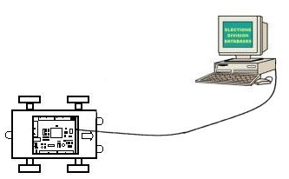
This option was considered primarily because of its simplicity of design and the incomparably low cost per unit. Implementing PC Based communication merely requires a serial cable and some simple Java code. The development of the code would not be overly complex because of the libraries included in the Java programming language. However, because the PIC chip is programmed in assembly, the interface responding back to the PC would be more difficult to design, yet a serial communication protocol would need to be implemented on the PIC whether or not PC Based Communication was selected. The obvious benefits of implementing PC Based Communication are ease of setup and testability.
Figure 2 – PC Based Communication
However, use of PC based communication would greatly impact the effectiveness of the project because the robots would need to be “tethered” to a computer and dependant upon it for the exchange of information. This would cause many issues in terms of movement with multiple robots and greatly decrease their effectiveness.

2.2.2 Mica2dot RF Communication

The Mica2dot motes are rather complex and sophisticated wireless modules. They contain far more hardware then a simple wireless antenna. The Mica2dot motes use an RF transceiver which has it’s own protocol which is used in all Mica2 products. The protocol has support for implementation of many of the desired features such as ambient monitoring to ensure that transmission does not begin from one mote until there is not a mote currently transmitting. The Mica2dot device also has an Atmel ATMega microcontroller soldered onto its circuit board. This allows the mote itself to be programmed with code to handle different types of instructions, or possibly recode the mote itself during runtime. However, all of the additional functionality makes the objective of simply transmitting information a far more complicated task.
All wireless transmissions made by the Mica2dot are still accomplished by an RF transceiver. The signal sent uses a 916 MHz transmission that has a range of approximately 145 meters. All RF devices inherently have multi-cast, 360 degree, transmission, allowing all Mica2dot motes within range to receive the same signals. This simplifies transmission algorithms because it does not require message forwarding, yet at the same time opens up more opportunities for wireless crosstalk to occur.

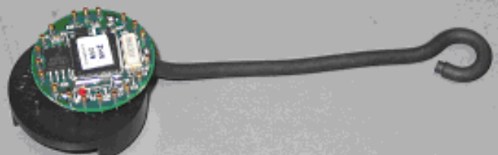
Figure 3 – Mica2Dot Mote

The Mica2dot motes are programmed in a specialized version of modular C code. The code runs on a micro-operating system called TinyOS that uses task scheduling in order to complete actions requested during runtime. As shown in Figure 3 – Mica2Dot Mote above, the Mica2dot is approximately the size of a quarter, easily allowing its integration onto the mobile sensor platform. The interface between the Mica2dot mote and the PIC controller would be theoretically simple by the use of the UART (Universal Asynchronous Receiver Transmitter), which is used for all serial communication with the mote, including reprogramming. It also contains an array of analog and digital Input/Output ports in case more are needed.

2.3 Electronics and Sensor Concept

The electronics on the robot consist of three main elements, a PIC to control the sensor platform’s actions, a set of motor controller chips which will interface output from the PIC to the motors themselves, and sensors which will be used to sense objects and terrain around the sensor platform. There are two main types of range sensors that can be used in this project, which are infrared sensors, and ultrasonic sensors. The robot will need to utilize one of these types of sensors in order to determine the location to which it must travel. In order to simplify algorithms on the robot as well as to give the formation a group bearing, compass sensors were examined as well.

2.3.1 Infrared Sensors

Infrared sensors function by emitting a special wavelength of light invisible to the human eye unaided, infrared, and then calculating the angle of return of the light. This method uses simple trigonometry to determine the distance the sensor is from an object. However, if the light is blocked or reflected away from the sensor, it will not be able to detect the object. The method of measuring distance is shown below in Figure 4 – Infrared Distance Measurement.

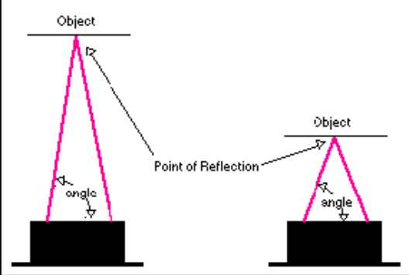
Figure 4 – Infrared Distance Measurement

The infrared sensor, which would fit the project most aptly, is the Sharp R144-GP2Y0A02YK infrared sensor. It has a range of 20 cm to 150 cm, which should have sufficient range for our purposes, but it was mainly chosen for the cost. The minimum range of the sensor is incurred because the angle of return becomes too wide for the width of the sensor, causing the emitted infrared beam to be unable to be sensed.

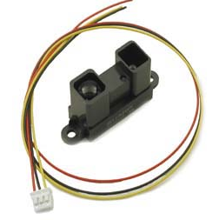
Figure 5 - Sharp Infrared Sensor

Each infrared sensor device would cost approximately $15, allowing multiple such sensors to be placed on the robot. Most infrared sensors do not have a maximum range as far as the R144-GP2Y0A02YK, unless they are significantly more expensive. If the chassis of the robot is a mere 20 cm across the sensor will need to be capable of sensing at least 150 cm in order to allow the mobile platforms to move freely.

2.3.2 Ultrasonic Sensors

A second option for sensor selection considered by the team was the ultrasonic sensor, also known as a sonar sensor. Sonar sensors detect objects by emitting a very high frequency sound wave, inaudible to the human ear. The sound wave will then travel until it reflects off an object and back to the sensor itself. Recording the time the pulse of sound took to return and multiplying it by the distance sound travels per second can then measure the distance.

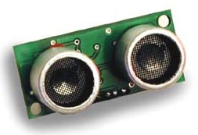
Figure 6 - Devantech SRF04

The sonar sensor selected by the project team is the Devantech R93-SRF04 Ranger. This sensor has a range of 3 to 300 cm, but costs nearly twice as much as the infrared sensor. The minimum distance of the sonar sensor is incurred because there must be a time delay between sending the sonar pulse and enabling the receiver.
The benefits of the sonar sensor are not to be taken lightly. The measurement given by the sonar sensor is linear instead of a voltage curve as is the case for an infrared sensor, making it much simpler to interpret. The minimum range is significantly smaller, allowing closer objects to be sensed, as well as doubling the maximum sensing distance. The only downfall of such an option is that there is generally more interference between multiple sonar sensors operating at the same time. This occurrence is known as crosstalk.

2.3.3 Compass Sensor

The PIC controller on the mobile platform has limited processing power and memory. In order to simplify the formation topology algorithms, as well as give the robot more accuracy in movement direction, a compass sensor may be integrated onto the circuit board. The compass sensor would also be able to give the group of robots a global direction, allowing them all to face in the same heading and travel as a team.
A compass sensor works by having two magnetic field sensors, which are sensitive enough to detect the Earth's magnetic field. Two of them mounted at right angles to each other can be used to compute the direction of the horizontal component of the Earth's magnetic field. The sensor can then return a value from 0 to 360 degrees in 0.1-degree increments.

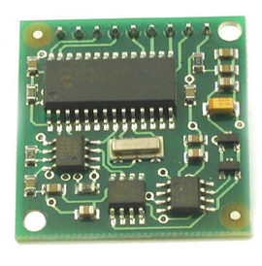
Figure 7 - Devantech Compass

The majority of compass sensors are quite expensive; however the Devantech R117-COMPASS chip should be accurate enough for our needs. The integration of a compass sensor is not essential to the project, but it would add a significant degree of robustness and simplicity to the project, making it well worth looking into.

2.3.4 Motor Controllers

In order to interface the PIC’s simple TTL output signals to the motors themselves, they command signals must be sent through either a single motor controller or a pair of motor controllers in order to send the proper command signals. There are significant advantages to both of the aforementioned options. If a single motor controller design is selected, a chip such as the MC3479 Motor controller driver can be used. This controller is simple because each pulse sent to the controller translates into a single pulse sent to the motor. Motor rotation is controlled by sending either logic one or zero to the direction input pin to go forward or backward respectively. However, the motors require a significant amount of current to move and if all of the current is passing through the motor controller driver, it will overheat. The second option is to use two chips such as the UC3770 High performance stepper motor drive circuit. This chip requires two signals pulsing with the same amplitude, but differing phase. Depending on the relative phase of the two signals, the motor will move either forwards or backwards. While this is slightly more complex, these chips can handle significantly more maximum current, which produces more torque in the motors, yet allows the current to be limited while the robot is not moving.

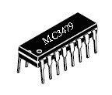
Figure 8 - Motor Controller Driver

2.3.5 PIC Microcontroller

The PIC microcontroller selection was overwhelming at first. There are thousands of versions of PIC microcontrollers and it is simple to waste time getting caught up choosing the part. Previous CE design teams have used the PIC18F4320 by Microchip and there are a significant number of them available for student use at RIT. The PIC18F4320 has nearly 40 Input/Output ports and a very significant amount of specialized functionality that can be implemented using control registers. It has an internal clock that can be run at 8MHz, which should be more than ample speed for our project.

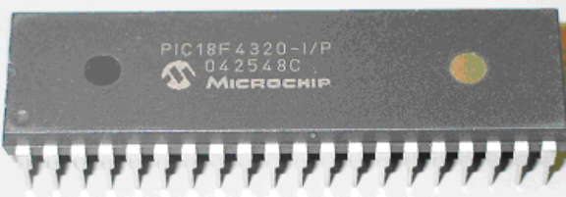
Figure 9 - PIC Microcontroller

Aside from being free, it is one of Microchip’s newer PIC versions and free samples can be obtained for educational projects. Using a PIC instead of another microcontroller is effective for the project because of the low power requirements and versatility.

2.4 Locomotion Concept

In order to make the robot move effectively, an efficient method for locomotion was desired. The rest of the chassis can be designed around the chosen method, since mobility is so important to the project. The first step in choosing a method was to brainstorm. The chassis frame needs to be able to support all of the equipment, sensors, controllers, etc., while being stable and agile. It needs to be able to move both forwards and backwards as well as turn either counter clockwise or clockwise. The precision of the platform’s movement is also of major importance. This is because measuring motor rotations will be the majority of the calculations for how far the robot has moved. An analysis of some of our options is shown in the table below.

 | Treads | Eight Wheels | Four Wheels | Two Wheels | Legs
Skills available? | Yes | Yes | Yes | Yes | No
Implementation possible? | Yes | Yes | Yes | Yes | No
Will it meet requirements? | Yes | Yes | Yes | Yes | Yes
Equipment available? | Yes | Yes | Yes | Yes | Yes
Will the robot perform well? | No | No | Yes | Yes | No
Is the cost acceptable? | Yes | No | Yes | Yes | No
Is this method an Option? | No | No | Yes | Yes | No

The first option, treads, was discarded because of the power requirements for overcoming the friction would be difficult to achieve with the rechargeable batteries available to the team, making the robot slow and less agile then desired.
The second option, more than four wheels, was discarded because it is cost prohibitive as well as inefficient to have so many motors running at the same time. Once again battery power is limited and the friction incurred by all of the motors attempting to move at the same time would cause a serious loss of mobility.
The last option, legs, was discarded because of the complexity involved. There are pre-built chassis available which implement the use of legs to move a robot, however they are costly and require a decent amount of controller power to implement. In order to save on complexity and design simplicity, this option was not feasible.

2.4.1 Chassis Concept

A major consideration in the chassis design is the weight of the mobile platform. The lighter the platform is, the less energy it will require to move, and the more agile it will be. In order to reduce the weight to a minimum, a very compact chassis must be developed.
The largest component to be integrated into the mobile sensor platform will most likely be the circuit board. After a preliminary design has been proved to be efficient, a printed circuit board can be made which will allow multiple robots to be fabricated easily and correctly without a lot of painstaking soldering. Generally, the minimum size for cheaply made printed circuit boards is around two and a half inches by four inches. In order to accommodate any orientation of a printed circuit board, the chassis will need to be a minimum of four inches in both horizontal directions. Using this as a guide, the chassis will only be expanded in order to accommodate components previously un-thought of.
From our research, we focused on four different drive systems. One of these included the original four-wheel drive system. This was included as a means of comparing the other options available. As a result, we were able to make a wise decision on the best locomotion system for our design.

2.4.1.1 Differential Drive

The differential drive system is very simple; often the drive wheel is directly connected to the motor (usually a gear motor--a motor with internal gear reduction--because most motors do not have enough torque to drive a wheel directly). Unfortunately, it can be difficult to make a differential drive robot move in a straight line. Since the drive wheels are independent, if they are not turning at exactly the same rate the robot will veer to one side. Also, the non-driven wheel or castor wheels can cause problems if the robot reverses its direction. This may result in a translational heading error.

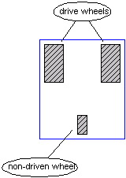
Figure 10 - Differential Drive

2.4.1.2 Synchro Drive

The synchro drive system is a two motor, three/four wheeled drive configuration where one motor rotates all wheels to produce motion and the other motor turns all wheels to change direction:
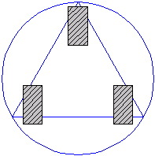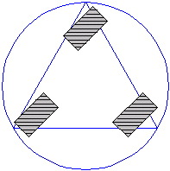
Separate motors for translation and rotation make control much easier. Straight-line motion is guaranteed mechanically--there is no need for interrupt-based control as in the case of the differential drive method, but the mechanism that permits all wheels to be driven by one motor and turned by another motor is fairly complex. Also, wheel alignment is critical.

2.4.1.3 Car Type Drive
Car-type locomotion is very common in the "real world," but not as common in the "robot world." A pair of driving wheels and a separate pair of steering wheels characterizes car-type locomotion. It is one of the simplest locomotion systems to implement with one caveat: the turning mechanism must be precisely controlled, but planning is difficult because the system is non-holonomic.
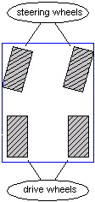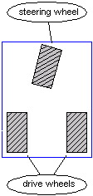

2.4.1.4 Skid Steer Drive

Skid-steer locomotion is commonly used on tracked vehicles such as tanks and bulldozers, but is also used on some four- and six-wheeled vehicles.
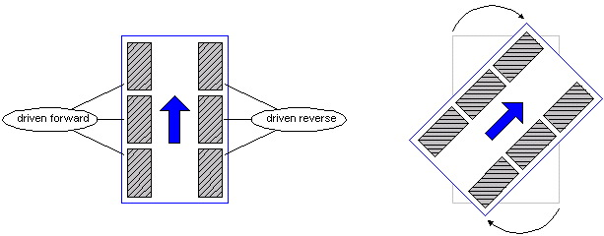
It is closely related to the differential drive system, replacing the caster wheel with extra drive wheels. It has the same disadvantage: moving in a straight line requires the wheels on each side to be turning at the same speed, which can be difficult to achieve. The advantage of skid-steer is increased traction and no "caster wheel effect".

2.4.2 Four Wheels

Four wheels will allow the team to design a very stable platform that will be able to support and move a significant amount of weight. This design is rather common on robots and has proven to be successful. The only immediately obvious point against a four motor design is that it would require more power to move than a design with only two wheels.

2.4.3 Two Wheels

While two wheels alone would not allow for a stable chassis, a pivot point can be added in order to help stabilize the robot and keep it from tipping or tilting. Selection of a proper pivot will be discussed shortly. The major advantages of a two wheel design are the small amount of power required to turn only two motors, as well as the fact that the wheels would never be straining against one another when the robot needs to pivot. In terms of rotating the robot smoothly, the two-wheel design has a significant advantage.

2.4.3.1 Castor Pivot

Castor pivots are common in everyday life, as most conventional tools use them (projectors, shopping carts, etc…). A castor pivot is very simple and easily purchased at many stores. However, they have one major disadvantage. When a castor needs to change direction, they often do not do so smoothly. There is a certain amount of force that is needed to rotate the caster so that the wheel if facing in the proper direction before it can spin smoothly. This could become a major problem since the robot is constantly using the number of rotations of the motor as a method to measure distance.

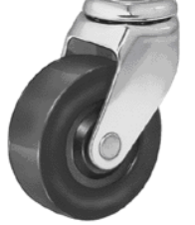
Figure 11 - Castor Pivot

2.4.3.2 Ball Bearing Pivot

A ball bearing pivot would be slightly more difficult to obtain, yet it would remove the concerns of not moving smoothly upon direction changes. Ball bearings are generally heavier and slightly more difficult to work with, yet have is a significant advantage.

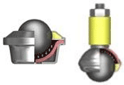
Figure 12 - Ball Bearing

2.4.4 Motors

A rather significant issue, which has been mostly glossed over so far, is the decision on what type of motor should be installed on the chassis. There are two major categories for motors that must be examined. These are continuous DC motors, and stepper motors.
DC motors are more common and easily available. They are generally more powerful, easier to interface to, and allow the robot to move faster. However, despite these advantages, they also have a serious disadvantage. They have no method for exact control of the distance to travel. They simply turn on and drive and slowly turn off. This is a problem for our project because the robot needs to have a method by which it can drive a specified distance and stop to survey its surroundings. It would be possible to implement our own control device to determine the number of rotations of the wheel by having a laser get interrupted each time the wheel has rotated. However, this measurement is not very precise and therefore the DC motor must be examined critically in order to interface it properly with the rest of the mobile platform and achieve the desired goals.

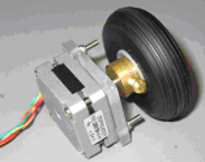
Figure 13 - DC Stepper Motor

Stepper motors function by sending pulses of power to the motor rather then a constant signal. Each pulse of power corresponds to a single step of the motor, thereby giving the controller a direct way to measure the distance traveled. These motors however also require a much larger amount of current to maintain accuracy. This is because each motor has a large magnet that controls the stepping and must be energized at all times, even if the robot is not moving.
3.0 Feasibility Assessment

In order to remain constant in the overview of the project, the feasibility assessment will be broken down into the same three main categories as the concept development. These categories are Chassis Design, Electronics & Sensors, and Communications. At the end of each section are the initial part selections as well as the cost associated with each part.

3.1 Communication System Feasibility

The main concern with the implementation of the communication system is ease of implementation. If the mobile sensor platforms can communicate with outside objects, it becomes much simpler to test and debug the platform. If either the wireless communication or the PC based communication is successful, information can be easily sent to the PC via the wireless mote programmer or the direct link. With this option added, much more powerful tools are available to overcome obstacles on the project.

3.1.1 PC Based Communication

PC based communication is rather simple to implement in an object oriented programming language such as java. Java contains many packages and libraries, which can handle much of the inbound and outbound communication, allowing a useful interface to be designed without the need to delve into different protocols on the PC. The team contains three computer engineers who are all proficient in the Java programming language, and implementing an interface should not be overly time consuming and should not incur any additional expenses to the project. However, the robots must be autonomous by the end of senior design II, so if PC based communication is to be developed it must be able to be directly ported into an interface into a wireless controller. Otherwise, the time spent on developing a communication interface will be mostly wasted, as the interface will have to be rebuilt before the end of the project.

3.1.2 Mica2dot RF Transceiver

The integration of the Mica2dot RF Transceiver adds a significant amount of functionality to the system. The wireless communication no longer becomes overhead, but instead gives the system increased processing power. This is because the Mica2dot mote has a built in microcontroller of its own. This means that the interface between the main PIC microcontroller and the wireless interface can be simplified because once data is transmitted to the Mica2dot mote the data can be processed, packaged, and then sent intelligently in order to avoid data collisions.
The Mica2dot mote also has some basic power saving features that allow the motes, which are battery operated, to have a longer lifespan and reduce network drain. The API available for programming the Mica2dot motes allows for efficient network regulation, and effective transmission. The motes are programmed using a modular version of C, which should be familiar to most of the programmers in the group. In terms of effectiveness and ease of use, the Mica2dot motes should be excellent. The only drawback of the mote is the price tag, which comes to nearly $135. However, as our mentor requested this method of communication, this price should not be weighed to heavily.

3.1.3 Communication System Conclusions

Although it would be very beneficial to implement basic PC communication quickly, after a review by the team, it has been decided to work on directly implementing the wireless communication first. There are two main reasons for this decision. First, manpower is limited and much of the work that would go into developing PC based communication would be nearly worthless by the end of the project. Secondly, the wireless motes use a modular version of C, which would be very difficult to interface with a Java program written in for PC based communication. In this aspect, very little would be learned about the necessary interface for the mobile platform during a Java implementation.
Implementing the Mica2dot is therefore one of the main focuses for the team as a whole. The integrated microcontroller and development API should allow for easy integration with the other microcontrollers present on the mobile sensor platform. Easy integration will allow the team to concentrate more on the development of the platform itself and less on the background tasks of developing a communication interface.

Component | Price | Quantity
Mica2dot Mote | $135.00 | 1 Per Platform + 1 Base Station
Mica PC Interface Board - MIB510CA | $95.00 | 1 For Programming Motes

3.2 Electronics and Sensor Feasibility

The effectiveness of the sensor package integrated onto the mobile platform is of primary concern. However, there are significant physical limitations on size and weight of the robot as well as power consumption, cost, and measurement accuracy. All of these considerations together limit the selection of the sensors.

3.2.1 Infrared Sensors

Infrared sensors are characteristically used for object avoidance. This is because the sensors are very cost effective and require very little power to sense whether there is an object in its path. However, because of the nonlinear output it is difficult at best to determine the exact distance to an object, thereby making IR sensors only useful to determine if there is an object present. IR sensor require more calculations in order to process the information received, as well as a more difficult implementation code to successfully integrate the sensor onto the circuit board.

3.2.2 Ultrasonic Sensors

Ultrasonic sensors are characteristically used for more exact distance measurement. They are easily implemental because the measurement returned is the amount of time taken for the sonar wave to be sent and return to the sensor. This measurement is linear and since the speed of sound through air is known, the exact distance can be calculated if the microcontroller can acknowledge the return of the signal fast enough. Most microcontrollers can be run at approximately 8 MHz that is more than enough when converting the time delay into centimeters traveled.

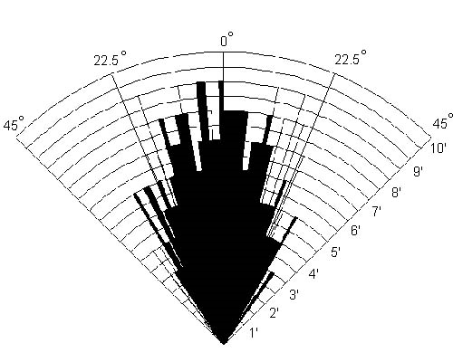
Figure 14 - Sonar Beam Pattern

Unfortunately sonar sensors require more power, are more expensive, and sense objects at a larger angle then an IR sensor. The increased field of view can be both a benefit and a hindrance. As shown in the figure above, the Sonar Sensor can see in approximately a 45-degree arc with the majority of the focus within 15 degrees of directly ahead. This means that while there is the possibility that the sonar will detect objects slightly to the side, the majority of the time, the sonar will only sense what is directly in front of it.
In a direct comparison between an IR sensor and an Ultrasonic sensor, a few main points become apparent. The IR sensor is cheaper and more power efficient, while the Ultrasonic sensor is easier to interface to a microcontroller and more accurate in terms of measurement distance.

3.2.3 Compass Sensor

A compass sensor is functionally desirable because it would add a global direction to the group of mobile sensor platforms. In order to achieve the maximum benefit out of the compass, it needs to be calibrated to its current latitude. Once the compass sensor has been calibrated, it will achieve a resolution of 0.1 degrees accurately.
There are two significant drawbacks to adding a compass sensor. It adds complexity near the beginning of the integration process and is priced at around $50. The compass sensor would have to be integrated onto the circuit board and connected with the main microcontroller. Both of these tasks would require a significant amount of manpower because of debugging issues. However, it would simplify algorithms that would need to be developed during senior design II.

3.2.4 Motor Controllers

Using a single motor controller, the MC3479, would be a very efficient method for controlling the mobile sensor platforms. There is a direct relationship of one controller for each motor, it can draw a maximum of 400mA of power, and it would be simple to code an interface into the main microcontroller to utilize the motors themselves. The MC3479 is also cheaper then the alternative and would require less time to integrate. However, there is one significant drawback to its use. This problem is that 400mA of current would be very near the minimum possible current to rotate the motors accurately. This is a significant problem because if the motors are underpowered and sometimes do not rotate properly because of friction, measurements will be off and the robot will become significantly less effective.
Using two UC3770 high performance stepper motor drive circuits is less efficient, but it would undoubtedly increase the functionality of the robot. The UC3370 will allow approximately one amp of current through each chip at a time, allowing for significantly more power to the motors at any given time. This causes a significantly larger drain on the battery. However, it also has built in current limiters that can allow the microcontroller to reduce the current from 100% to 20% in 20% intervals. This would allow the project team to put a huge amount of current through the motors while movement is desired, yet severely limit the amount of current through the motors during periods where the robot is stationary. It is believed that this method of control would allow longer battery life overall while giving the motors greater power during times of need.
The drawback of using these controllers would be the difficulty of integration. The addition of two UC3770 controllers per motor adds a significant degree of complexity to the mobile sensor platform’s electronics as well as utilizing more Input/Output ports on the microcontroller. The increase in complexity for coding the microcontroller is not overly significant, but it should not be ignored in any case.

3.2.5 Electronics and Sensor Conclusion

In order for the mobile sensor platform to move, sense, and interpret its surrounding environment accurately and efficiently, the following selections were made.

- Distance sensing will be done using ultrasonic sensors, namely the Devantech SRF04 Ranger. This will give the robot the accuracy and precision necessary to locate objects and move to a precise location without significant algorithms needed to understand the reading given by an IR sensor.
- A Compass sensor will be integrated onto the chassis as well. While this will add significant complexity to the earlier stages of the project, it will allow for a far more robust and simplified final design. The team believes that this addition will be a benefit rather than a hindrance.
- The UC3770 high performance stepper motor drive circuit chips will control the motors. While this method also increases the complexity of the project it allows for more advanced control of the motors themselves increasing the effectiveness of the electrical design.
- The PIC 18f4320 will be integrated as the main microcontroller. This chip is readily available to the project team, is cost effective, and more than sufficient for any requirements that are foreseeable in the near future.

The overall pricing for the electrical components analyzed in this section is summarized in the table below.
Component | Price | Quantity
Devantech SRF04 Ranger | $36.00 | 2 Per Platform
R117-COMPASS | $51.00 | 1 Per Platform
UC3770 Motor Controller | $5.56 | 2 Per Motor
PIC18F4320 | $8.17 | 1 Per Platform

3.3 Locomotion Feasibility

There are two main concerns in the area of chassis feasibility. These concerns focus mainly on the topic of a pre-built platform. The two questions that need answers are:
Should a pre-built platform be used, and if so which one?
If the team constructs its own design what will be the method of locomotion?

Since the project team includes two mechanical engineers, building an entirely new chassis should not be that difficult with the plethora of models available as well as the machine shops on campus. Materials should also not be overly difficult to obtain as RIT has a supply of commonly used materials.

3.3.1 Pre-built Chassis

The advantage of getting a pre-built chassis is rather enormous as long as the design specifications of the project are within the operating specifications of the chassis purchased. This is rather simple, but massively important. The concept behind this fact is simple. A pre-built chassis is designed to be cost effective to produce whatever results it is designed for. It must be cost effective; otherwise a similar, cheaper robot that produces the same results will outsell it and remove the more costly robot from the market. To this effect, pre-made robots have limited functionality.
The group looked at a significant number of pre-built robots that were designed for a variety of purposes, playing soccer, maze walking, robot to robot combat, and more. The initial response was that a pre-built chassis is a great idea. The chassis is solidly constructed, looks good, and has a significant amount of functionality built into the robot itself. However, upon closer examination, some of these advantages became disadvantages. All of the designs had at least one of the following flaws, which rendered it useless:

- Limited Input and Output on the available microcontroller, cannot add sensors
- The motors cannot measure the distance traveled
- The motors cannot travel a precise distance based upon commands
- The microcontroller does not have enough processing power to handle the tasks to which it will be assigned
- The built in functionality is too complex to modify and therefore is rendered useless
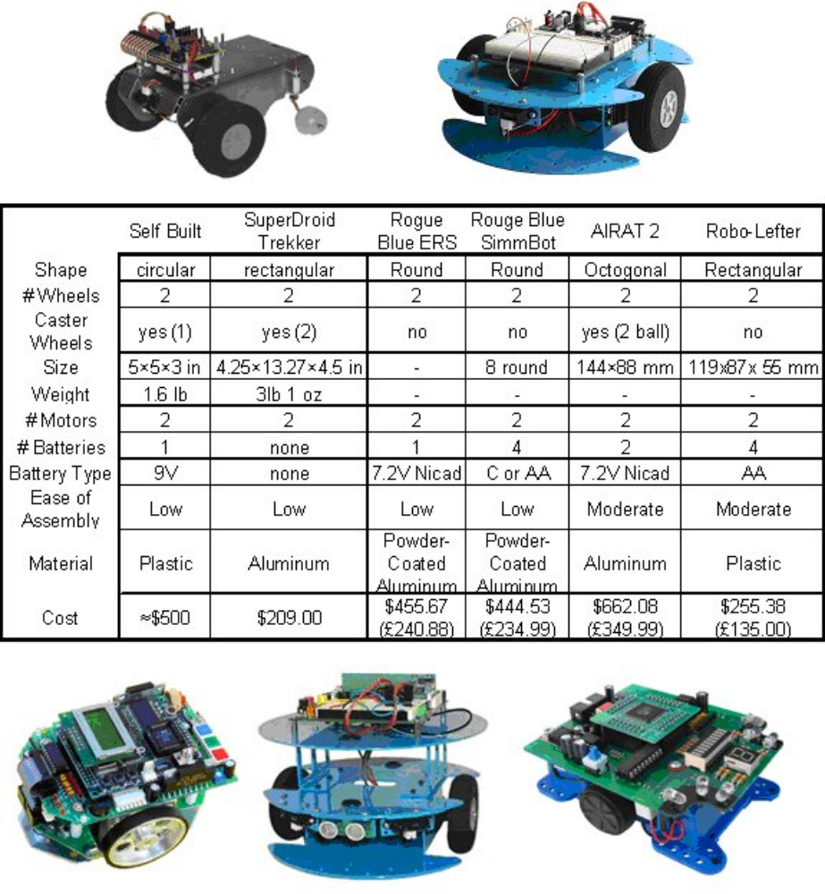
Figure 15 - Pre-Built Robots

For these reasons, too much functionality would have to be removed from a pre-built chassis in order to add on components that would allow us to meet the specifications that the project requires. This would be a waste of both time and money. In order for the group to be more efficient however, some of the chassis designs were noted and the group used these as a model to select how the project’s chassis design would develop.

3.3.2 Custom Built Chassis

Designing our own chassis for the mobile sensor platform is a significant task to undertake, however, the group contains two mechanical engineers who felt they could complete the task without too much difficulty. Their confidence allowed the team to rest assured that project would progress with a robust, malleable chassis that could be upgraded to suit the needs of the project, instead of modifying the project around a chassis which it would be unwise to alter.
After examining the concepts for locomotion, two important options arose for locomotion. The sensor platform would use the 39BYG Motors available to us from the projects lab, with either two or four motors attached to each chassis. After examining the strength of the motors during an early test, the group decided that two motors should be sufficient to provide motion to the chassis. Since two motors were proven to be effective with approximately 3 pounds of additional cargo weight, there was no need to upgrade the chassis to utilize four motors. Four motors have the following disadvantages:

- Requires more complex code on the PIC to control the direction and speed
- Requires more Input/Output pins on the PIC to talk to the motors
- Requires more power, reducing battery life of the platform
- Increases the friction encountered when turning the robot

These four disadvantages swayed the opinion significantly allowing the project team to proceed, designing the mobile platform to handle two motors instead of the possible four. A two-wheel design also had a benefit that was unexpected; it allowed rotation about the central point of the robot to be made more easily. This allowed the code for the robot to be written in such a way as to internally model the robot as a circle whose diameter was the width of the platform.
As a means of making the platform light and cheap, the team decided to utilize Acrylite FF sheets. Acrylite is a lightweight (1/2 the weight of glass & 43% the weight of aluminum), rigid, and weather-resistant thermoplastic. It is also, dimensionally stable and resistant to breakage, and can be easily sawed, machined, heat-formed and cemented.
It was also decided that the sensor platform would have multiple levels upon which different components would be attached. The bottom level would hold the battery and ball bearing pivots, the mid-level would hold the sensors, and the upper level would contain the electronics giving easy access for modifications.

3.3.2.1 Motors

Initially, the team performed a preliminary analysis on the motors, before actually making the model, based on specifications found on the Internet. From this analysis, we came up with a weight range for which the motors should be able to tolerate. This helped in seeing the feasible size and weight of the overall robot design. Also, from empirical studies, it was recommended that we needed at least 8 ounce-inches (576 gm-cm) of the motor’s dynamic torque per pound of robot. This would provide minimum movement. This also yielded a required minimum of 0.02825 N∙m/lb per motor. Using the minimum holding torque value rated on the motor specifications, we calculated that our dynamic torque was approximately 0.0325 N∙m/lb per motor. Therefore, we estimated that each motor was strong enough to move at least one and a quarter pounds of robot mass, and therefore our model should be designed to weight no more than 2.5 lbs.

3.3.3 Locomotion Conclusion

In order for the mobile sensor platform to meet all of the desired requirements without introducing unneeded overhead, the project team decided to design and build a chassis instead of buying a pre-fabricated one. In order to save on power consumption and processing power, the platform will be designed with two wheels using a ball bearing as pivot points. The overall pricing for the components analyzed in this section is outlined below.

Component | Price | Quantity
Tires | $5.99 | 2 Per Platform
Stepper Motors | $6.49 | 2 Per Platform
9.6V Rechargeable Battery | $8.99 | 1 Per Platform + Backup
Battery Charger | $26.99 | 1 For The Project
Acrylite FF sheets | $9.99 | 1 Per Platform
Ball Bearings | $9.99 | 1 Per Platform

3.4 Feasibility Conclusion

Upon completion of the feasibility analysis of the three major components, many concepts had been evaluated and discarded for their complexity or inefficiency. The final selection of concepts requires more work on the part of the project team, but should allow the design of a far more robust and upgradeable final product.
The cost for the initial prototype will be significantly more than the cost associated with the mass-produced sensor platforms because of the need from programming tools, battery chargers, and components broken during the testing phase. A summary of the costs incurred by the project is shown below.

Aspect | Initial Cost | Additional Unit Cost
Communications | $365.00 | $135.00
Electronics & Sensors | $142.29 | $142.29
Locomotion | $89.91 | $43.94
Totals | $597.20 | $321.23

4.0 Performance Specifications

In order to efficiently build a chassis, design must first take place. The performance of the system as a whole can be broken down into three major categories: Mechanical Design, Electrical Design, and Software Design.
The group was charged with the task of constructing of a prototype mobile sensor platform by the end of Senior Design I. This prototype must be completely functional; however, it is not necessarily the final version of the platform. It must be able to move independently and smoothly, utilize its sensors, and communicate using wireless technology.

4.1 Mechanical Design Objectives

Although the design will not necessarily be complete the prototype must meet the following objectives:

- Independence – The platform must be able to support and carry all of the equipment needed to achieve functionality
- Platform Size – In order to achieve minimum weight, the platform must be as small as possible.
- Weight - The weight of the platform with all components attached must be as light as possible.
- Speed – The platform must be able to move quickly to any position on a flat surface
- Mobility – The platform must turn smoothly around it’s center without slipping
- Ease of Assembly – The platform must be easily assembled in a straightforward and concise manner.

4.2 Electrical Design Objectives

Although the design will not necessarily be complete the prototype must meet the following objectives:

- Idle Power Consumption – Components that are not actively in use should be shut off in order to minimize the amount of wasted power on the robot. Proper power management should be implemented to insure reduced power consumption for communication and waiting for messages.
- Platform Uptime – Battery lifetime should exceed at a bare minimum the amount of time to perform the selected topology and show functionality
- Heat Regulation – Heat generation during runtime should be kept to a minimum so that components will not be damaged by allowing the platform to work under heavy stress continuously.
- Jitter Toleration – All electrical signals should have a noise margin that allows for error in transmission caused by environmental interference.

4.3 Software Design Objectives

In any software system, especially an embedded system, program size or memory constraints play a major role in the design of the system. This is because for embedded system, there is usually very limited space available for the programmer to use. This constraint is even more severe because on embedded systems, the program is usually not as easy to debug or upgrade, forcing the programmer to be more robust and thorough in design and implementation.
The microcontroller selected, the PIC18F4320, controls all major functionality of the mobile platform, aside from communication. It has 8 kilobytes of memory storage, while the Mica2dot contains 128 kilobytes of memory storage. While the Mica2dot contains much more code space, it is also a much more complicated device which has a custom-built operating system installed, called TinyOS. TinyOS controls most of the low level functionality of the wireless mote, allowing programmers to develop event driven code that reacts to incoming messages.
Since the code is written to the PIC chip, it must be removed and reprogrammed for any code changes to take effect. In order for the mobile platform to function in differing environments, without constant reprogramming, the code must be robust enough to allow the system to be capable of dealing with unforeseen obstacles and interference, whether electrical or physical.
The final code design must meet the following objectives.

- Movement Control – The platform must be able to move effectively to any desired location either visible or relayed based upon the platform’s current position. This included turning accurately to varying angles and traveling varying distances.
- Communication Control – The platform must be able to communicate effectively with other platforms in order to send information on its current and future status. This information is critical to allowing the platform to work as a coherent team. In this manner, all messages sent should be received and acknowledgements of receipt or lack of receipt must be sent to ensure all data arrives at the appropriate destinations.
- Sensor Control – The platform must be able to effectively use all of its sensors to examine and navigate through unknown terrain without collisions that could be damaging.
- Topology Control – The platform must be able to differentiate between commands relating to different formation topologies and interact appropriately with the other platforms to carry out the mission of the selected topology.
- Timing Control – The platform must be able to delay for periods of time in order for it to be able to wait for user commands or delay so that communications do not overlap one another.

4.4 Mechanical Performance Specifications

In order to achieve the mechanical design objectives, certain specifications must be observed:

- Overall Platform Size: The final dimensions of the platform cannot exceed the dimensions 8” x 8” x 8”.
- Overall Platform Weight: The final weight of the platform cannot exceed five pounds.
- Assembly: The final platform will be constructed with removable fasteners to allow for disassembly.

4.5 Electrical Performance Specifications

Any electrical component attached to the platform has voltage and current requirements associated with it, which must be observed in order for the final product to function properly. A listing of these specifications is as follows:

- System Power: One 9.6 volt 1600 mAhr battery will power the entire assembly
- Motor: 2 Motors with maximum 12-volt inputs with a maximum operational current of 2 Amps.
- Motor Controllers: 4 controller chips with maximum input of 5 volts at 1 Amp.
- PIC Microcontroller: One PIC with a maximum input of 5 volts and 15 mA
- Mica2dot Mote: 1 communication processor drawing 50 mA peak at 3 volts
- Ultrasonic Sensors: 2 sonar sensors drawing 50 mA peak at 5 volts
- Compass Sensor: 1 compass sensor drawing 20 mA peak at 5 volts

Using an effective power management scheme it is expected that battery lifetime will exceed 30 minutes.

4.6 Software Performance Specifications

In order to achieve the software objectives, the following specifications must be obtained in the final product.

- Software Coding: All coding on the PIC will be done with assembly and verified on a regular basis. All coding for the Mica2dot mote will be done in modular C and follow the coding standards for TinyOS.
- System Testing: The system will be designed in a modular fashion allowing testing of individual components as well as the system as a whole.
- System Robustness: The system will be able to handle minor errors which are expected to possibly occur during runtime.

4.7 Design Practices Used

The team discussed a number of design practices to implement during the course of the senior project. The practices selected are:

- Design for Systems Integration: All components were purchased well ahead of schedule in order to allow for ample time to examine the interface before integration. All components that were selected for the project were examined for compatibility before being purchased.
- Design for Manufacturability: All manufacturability components on the chassis were expected to be designed and fabricated on equipment found on the RIT campus.
- Design for Recovery: The completed platform allows for disassembly of the components to allow for minor upgrades or replacement in the situation of a part failure.
- Design for Low Cost: All components were selected for both their functionality and their cost efficiency.
- Design for Efficiency: Since the system is largely embedded, resources are very limited on the platform. Therefore, all components need to work efficiently without waste to ensure proper robot lifetime.

4.8 Safety Issues

There are no set safety standards for this project as it is an experiment being conducted by in institute rather than an industrial process. However, there are some safety issues that were dealt with.

- The team must be careful in handling the robot at all times during the prototyping stage. The design will not be solidly constructed until it has been determined that the design is acceptable.
- All team members using machine shops will follow all safety guidelines during fabrication of any parts.

5.0 Analysis of Problem and Synthesis of Design

The initial problem the project team as a whole was faced with was the design and implementation of a single prototype platform. The platform must be fully functional, easily reproducible, and have the proper resources available to implement the more complex group functionalities desired for the second half of the Senior Design process.
In order to organize the amount of information necessary for analysis of the project, it has been broken down into two major categories, Hardware and Software. The hardware aspect of the design focuses mainly on the chassis design and electrical layout and functionality. The chassis design is chronicled in the Mechanical Design section while the electrical layout is in the Electrical Design section. The Software aspect of the platform will examine the code used for sensing, movement, and communication while briefly examining plans to implement topology formation, which will not be possible until multiple platforms have been built.

5.1 Hardware

The hardware design encompasses both the physical chassis construction as well as the electrical layout of components on the circuit board. These two issues will be discussed in detail in the following sections.

5.1.1 Mechanical Design

Aside from size and overall weight, motor performance played an essential role in our mechanical design concept. Because we were working with motors that were formerly available, a lot of the design was catered to how well they would work with added weight. It was not until after we performed a pilot test of the chassis’ payload versus the motor performance that we were able to design a fully functional and attractive robot model.

5.1.1 .1 Initial Prototype Designs

For our initial prototype we set out to build a compact chassis in order to minimize the amount of material used. This not only helped us to decrease the overall weight, but also provided us with a more durable and sturdy robot. Due to the flexible nature of our material, decreasing the overall dimensions enabled us to overcome any significant deflections. Because of our desire to use a two-wheel design, there was also the issue of stabilizing the robot in order to keep it balanced. Our size constraints limited us to using screws that were inserted into the bottom of the base plate at the front and back of the robot, and made level with the wheels. This was advantageous as it kept the weight to a minimum and made the fabrication process easier. However, the screws caused an increase in friction, which was a concern. The increased friction had a negative effect on the robots ability to turn accurately, as the screws are only suitable for very smooth surfaces.
In order to account for this problem our second prototype design included the use of two castor ball bearings in place of the screws, which encounter only rolling friction regardless of the robots direction of movement. This enabled us to turn more accurately, but required us to increase the dimensions to account for the larger castor ball. While the ball bearings increased the overall weight of the robot, this additional weight was not significant enough to cause concerns of exceeding our weight limit.
The prototype designs that were discarded are displayed below.
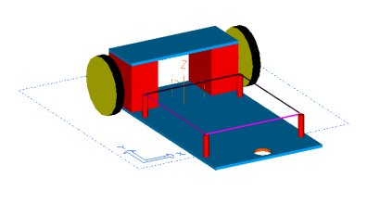
Figure 16 - Initial Prototype for Weight Testing

This prototype was too heavy and did not rotate around the center of mass.

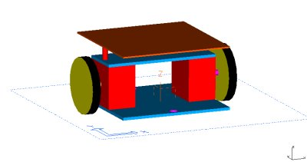
Figure 17 - Second Prototype
This prototype was far more effective, however it did not have sufficient space to mount all of the necessary sensors in locations where the sonar would have object to reflect off of.

5.1.1 .2 Current Prototype Design

Figure 18 - Current Prototype Chassis

This design has proved to be the most economical and space efficient model to date and is currently working effectively.

5.1.1 .3 Final Design Plans

For our final design we intend to continue investing ways to optimize our prototype design. This includes locating and incorporating a new type of castor ball bearing that is more suitable for our current robot. The new castor should be smaller and lighter, providing more leeway on desired dimensions and weight restrictions. The castor should also be more suitable for mounting purposes and improved aesthetics is preferable.
Final design plans also include determining the best option for mounting a compass chip. Since the magnets in the stepper motors can interfere with the readings from the compass, its location is critical. Currently, our options include developing a mast that would hold the compass an appropriate height above the motors. Another and more appealing option is to develop a shielding device using magnetic steel sheet metal. This would allow us to place the compass on or near the circuit board.

5.1.2 Electrical Design

A single 9.6 volt 1600 mAhr rechargeable battery will power the electrical system. This allows the entire platform to get power without having to worry about if separate components are low on power. The PIC microcontroller is essentially the heart of the mobile platform, as it connects to and controls the functionality of all of the electrical components. A simple block diagram of the system layout is shown below.

Microcontroller
PIC18F4320
2 Motor Controllers
UC3770
2 Motor Controllers
UC3770
Motor
Motor
9.6 Volt Battery
5.0 Volt Regulator
Rear Sonar Sensor
Front Sonar Sensor
Mica2dot Communication Mote
Compass Sensor
Figure 19 - System Block Diagram

5.1.2.1 Performance Testing

In order to understand the strengths and limitations of the selected components, performance testing is a primary concern for early development. Upon receipt of the motors, motor controllers, ultrasonic sensors, compass sensor, and Mica2dot motes each component was examined to see if it met the project requirements as its documentation stated.
The power consumption was also examined for each component to help regulate the amount of power drained from the battery during periods of use.

5.1.2.2 Sensor Performance

The sonar sensors selected, the SRF04 Ranger from Devantech, was surprisingly accurate during our testing. The sonar sensor functions by sending out a sonar pulse, enabling a receiver, and waiting for the signal to be returned. The distance is measured by tracking the time spent between enabling the receiver and waiting for the signal to be returned. The distance can then be directly measured by multiplying by the speed of sound (343 m/s in air).
This measurement is very straightforward and simple, allowing the accuracy of measurement to be very high. In order to establish that the sonar sensor was indeed as accurate as expected, a test was done to measure the amount of time passed for the sonar to discover an object at a selected distance. The graph of the results is shown below.

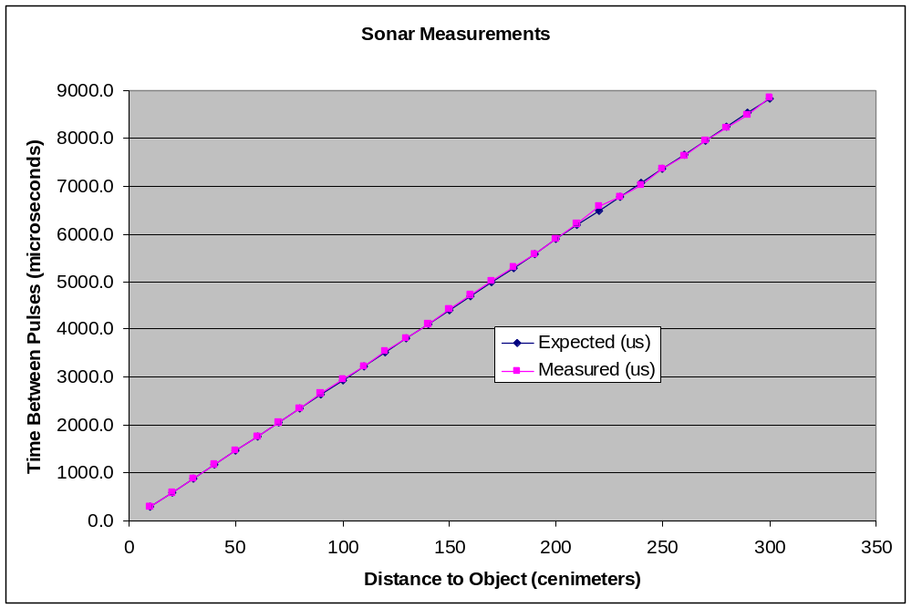
Figure 20 - Sonar Sensor Measurement Test

The sonar was actually more accurate than expected. However, this degree of accuracy may not translate directly into increased performance. The number of mathematical instructions available to use on a PIC chip is very limited (add, subtract, and multiply), and there is no decimal precision. This means that the accuracy of the mobile platform is now limited by the program written on it and no longer by the distance sensor itself (under good conditions) because there will be more error during the conversion to centimeters in the code then there will be by the sensor.

Examining the accuracy of the compass sensor was far more complicated then the sonar sensor. The only known method for the group of evaluating the accuracy was by eye. A normal magnetic compass was brought and compared to the digital heading reading given by the magnetic sensor. The values appeared to correspond exactly and if the documentation is believed, the sensors will be accurate to within 1/10th of a degree. Unfortunately, more in depth testing will have to wait until a second platform can be constructed and directed to travel at a certain heading. The variance between the two platform’s final locations will allow the project team to estimate the amount of error present on the compass sensors themselves.

5.1.2.3 Motor Performance

The motors and their controllers are of critical importance to the mission of the mobile sensor platforms. In order for the project team to get an idea of the weight distribution requirements, an early test was done to determine the maximum amount of weight available to distribute atop the chassis. This would give us some critical design parameters even though increased performance could be obtained by enhancing the design.
This test was carried out before many critical parameters of the system had been fully specified, so a minimalist chassis was developed upon which weights could be added in 200-gram increments. The initial motor controllers tested were the MC3479 motor controllers that were easily available on campus. While these controllers did not have the power requirements of the UC3770 controllers, they would be able to provide a basis for the test. Two motors were then attached to the chassis and electrical signal generators were attached to the motor controller leads in order to give the proper signals in order to move the motors.
The chassis was then tested for accuracy of movement by switching on the signal generators and examining the path of travel by the platform. The platform was also tested for turning accuracy in the same method. The results of the test revealed some surprising information.
First, the platform could handle approximately an additional three pounds of weight beyond the current chassis and battery pack. This was a significantly larger amount of leeway then the project team expected because faculty had questioned the performance of the motors.
The second piece of surprising information was that the robot was significantly more adept at rotating in place with a large load then it was at directional travel. This came as a surprise because teams with similar projects have had difficulties on obtaining smooth rotation for their platforms.
The results of this test allowed early weight limits to be set, as well as testing the basic concept of a two motor design. It was very successful in building confidence in the team of the functionality of our ideas and methods.

5.1.2.4 Power Management

The battery chosen to power the mobile sensor platform is a 1600 mAhr rechargeable NiMh battery. The terminal voltage of the battery is specified as 9.6 volts, however, after being fully charged, the voltage is actually larger. The voltage has been measured as high as 10.4 volts, but is generally around 10.2 or 10.3 volts. In order to conserve power, since battery life is limited, a couple basic power saving strategies will be implemented on the platform.
The first and most important power management strategy will be implemented on the motors themselves through the motor controllers. The motor’s power requirements are vastly larger than all of the other platform’s components combined. Since the power regulation of the motors is so critical, a motor controller was found that could regulate the amount of current sent to the motors in real time. The chip would then need to be controlled by the PIC, which would have to determine the desired actions of the platform. With this increased functionality added into the controllers, the PIC can now move the motors to full power during periods of movement, and return the motors to a low current state during periods of inactivity.
Stepper motors are unique because the motor requires, if unregulated, the same amount of current for movement as for inactivity. This is because the current that is required is used to lock a built in magnet that will only allow the wheel to move a small degree each time a pulse is applied to the motor controller. In order to maintain accuracy during runtime, the current to the motor cannot be completely shut off because the wheels would unlock and the robot’s position may change.
The second power management strategy that will be employed will be used to turn the sensors on and off when fresh sensor readings are not of importance. The sonar sensor will continue to draw small amounts of current in order to be able to recognize when it is supposed to send its initial sonar pulse, and the compass sensor will continue to take readings as long as it has power. Therefore, moderate power savings can be gained by employing a basic power switching circuit for both sensors that will remove power to the components when there is no need for sensor readings.
The Mica2dot currently has its own power supply, a 3.3-volt battery, with an expected lifetime of 7 years with the power management strategies employed by its operating system, TinyOS. Therefore, no power management strategies were needed for the communication aspect of the design.

5.1.2.5 Electrical System Schematics

After examining the datasheets for the various components, the following schematics have been designed and implemented on the mobile platform.

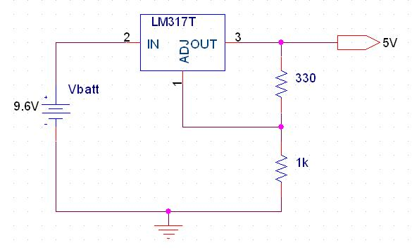
Figure 21 - 5-Volt Regulator

The 5 Volt regulator was implemented in order to provide the proper voltage to power the PIC18F4320 as well as the Ultrasonic and Compass sensors.

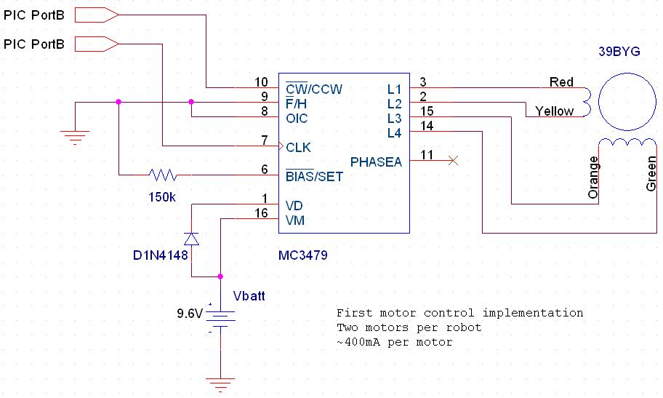
Figure 22 - MC3479 Motor Controller Implementation

The MC3479 was readily available to the project team and as such it was used in some early experimentation with the PIC and the Stepper motors. After examining the functionalities of the MC3479 controller a more suitable controller was selected for use in the final version of the project.

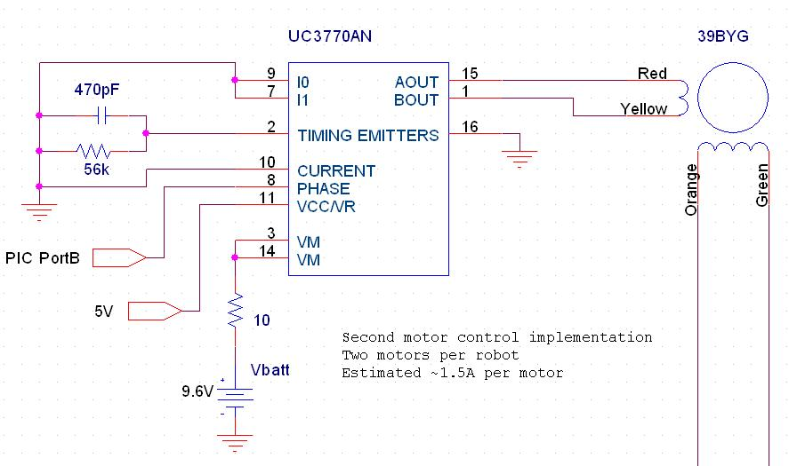
Figure 23 - Close-up of Single UC3770 Motor Controller Implementation

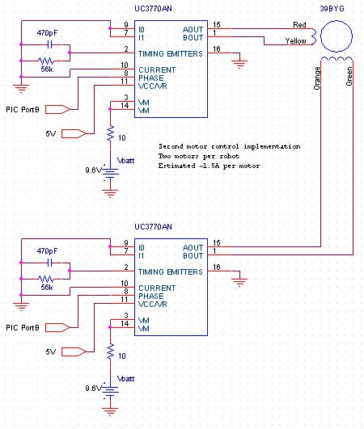
Figure 24 - Complete UC3770 Motor Controller Interface Implementation

The UC3770 schematic is a final version, and will be used in the final implementation of the mobile sensor platform as shown above.

5.2 Software

The project team was divided into three groups in order to make progress on different aspects of the platform. This left two group members to do the majority of the coding. In order to develop code that was efficient and modular, each area of the software was worked on in a methodical order, utilizing knowledge from previous modules. The individual modules that need development are the Movement Process, the Sensing Process, the Communication Method, and the Formation Topology.

5.2.1 Movement Processes

In order to make the robot move, the motor controllers require a pulse for each step the motor is expected to turn. Since the motor step is 1.8 degrees, there are 200 steps for each complete turn of the motor. Two hundred steps will allow the mobile platform to travel slightly under 19 centimeters. Thus, the number of motor ticks for the motor to travel over 25 centimeters will be larger than one byte. Furthermore, the variety of mathematical operations is severely limited on a PIC chip making conversions difficult. In order to maintain a high precision distances stored on the mobile platform should be converted to and stored as a number of motor ticks. While this measurement does not make much sense from a human perspective, from the platforms’ perspective, it is the easiest way in which to perceive the surrounding environment.
Once the distances are stored as motor ticks, movement is merely a matter of sending a regularly patterned pulse to the motor controllers, properly timed so that the robot does not attempt to travel too fast. The faster the platform travels, the greater the chance slipping will occur, causing error in the platform’s trajectory. Timing the pulse was found to be simplest by utilizing one of the onboard timers to toggle an output bit each time it interrupted declaring that the timer had expired. Utilizing the Timers and Interrupts on the PIC required a significant amount of research as well as debugging. However, the final product was well worth the wait because it created an easily updated method for movement that was completely independent from the rest of the code.
The code was designed in such a fashion as to be completely modular with the movement command in a unique subroutine that could be called or replaced with ease as long as the interface to the subroutine remained the same.
After debugging the code, a simple routing to make the robot travel in a figure eight was developed and run for 15 minutes to determine the accuracy of the distances traveled and the rotation of the platform. As time progressed, the figure eight pattern rotated slightly but remained largely unchanged. After approximately fifteen iterations through the pattern the ends of the figure eight had moved approximately one inch. With a compass chip integrated into the platform, such a minor error can be corrected by taking a heading reading at the end of each movement and adjusting accordingly.

5.2.2 Sensing Process

Integrating the ultrasonic sensors onto the chassis was no small feat either. Interfacing with the sonar sensors required a few set features that had to be implemented. In order for the sonar sensor to send a sonar signal, it must receive an electronic pulse with a length greater than 15µs, delay until the output signal changes, and then record the time passed until the signal changes again. This time measurement must then be converted into a distance measurement using the speed of sound as a constant.
For this to be achieved, delays had to be set up in the assembly code that would allow the program to stall for specified periods of time. By calculating the speed at which instructions are executed, it was trivial to create a loop that would delay the proper time limit.
Measuring the time until the sonar ping was received was accomplished by implementing one of the timers as a counter. This required setting some specialized registers in order to keep the timer from interrupting or overflowing. The timer is started when the return sonar signal is toggled and stopped when the return signal is toggled again. In order to keep the number of clock ticks within acceptable limits (16 bits is the maximum the counter can handle), the counter needed to be set to toggle on every fourth clock tick. Each clock tick will be:

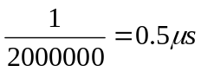
Figure 25 - Time Per Counter Tick

This means that the sonar ping will travel:

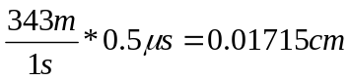

For each tick of the counter. This distance must now be converted into a specified number of wheel ticks. The wheel measures 3cm in diameter and it takes 200 ticks in order for the wheel to make a full rotation. This means that the wheel travels:

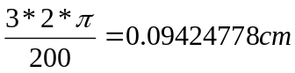

For each tick it makes. After a little mathematical examination it can be shown that in 11 clock cycles, the sonar ping will travel 0.18865 centimeters and that two motor ticks equals 0.18850 centimeters. Therefore, 11 clock ticks translate into almost exactly two motor ticks with a percent error of less than 0.1%. Even more advantageous is that the sonar ping must travel twice the distance to the object, once there and once back to the initial location. Therefore, the distance to the object is equal to the number of clock cycles counted during the ping divided by 11.
However, since division is not supported by the microcontroller, a rather complex algorithm that intelligently subtracts 11 and increments the count was devised. Having the mobile platform travel the distance it measures and stop once reaching it, allowed for verification of the code. Simply using a hand now allowed the team to examine the accuracy of the sonar sensor.
The sensing of other objects will take place by rotating the platform 90 degrees while taking object readings. The distances will then be stored with angles relative to the group heading, once the compass sensor is functioning.

5.2.3 Communications

Integrating communication through the onboard UART required a significant amount of research in new areas. However, it was not overly difficult to implement for testing purposes. A loop can be created that travels along a series of bytes that have the values to be sent stored in them and send them one at a time. Interpreting this information will be slightly more complicated when data is being received from the Mica2Dot controller, but will be accomplished be essentially reversing the algorithm used to send the information.
The packet structure that must be sent to the Mica2Dot is formatted as follows.

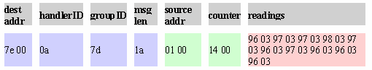
Figure 26 - Mica2Dot Packet Format

The packet can be interpreted as follows. The destination address comes first. This is used by the TinyOS protocol to filter messages to different groups that are assigned upon installation of code to the Mica2Dot motes. The handlerID declares the last object that received this message. This is used when an Ad Hoc network is created that must pass messages along before they reach their final destination. The group ID is the group ID that was assigned to the last mote that sent the message for the same reasons as the Handler ID. The Message length declares the number of bytes following, which can be up to a maximum of 29.
The rest of the information implements what has been designed of the mobile platform interface. The information following the message length is what will be sent directly to the PIC microcontroller. The information included in this packet will be the source address of the platform that sent the information, a counter informing the platforms what message this is, allowing platforms to recognize if a packet was missed. The following data is the sensor readings that must be shared in order for the platforms to gain information on what the other sensor platforms can see.

5.2.4 Topology

The goal for the second half of the Multidisciplinary Senior Design Project is to build three additional sensor platforms and develop and algorithm by which the sensor platforms can organize themselves into differing topologies. It is assumed that the starting positions of the sensor platforms will be randomized.
The general tasks that the sensor platform must be able to perform are:

- The platform must be able to identify objects in its environment and determine which are other platforms
- The platform must be able to effectively communicate its current location and status
- Determine the optimal positioning for all of the platforms in the topology
- Travel to its selected destination without collisions with any stationary objects

In order for the platform to be able to accomplish these tasks, the platform must be able to build an accurate representation of the relative locations of the other platforms through wireless communication. If the platforms are able to build identical representations independently, then any algorithm to select platform destinations will have the same results for each, allowing proper destination selection.

5.2.4.1 Procedure for Orientation

In order for each sensor platform to build an internal representation of its environment, it will have to spin, sensing objects in a 360-degree turn. Objects will be recorded as a distance measurement and a heading measurement using the compass chip. The platform will then transmit this data and wait for replies from other platforms. It will then match the data received for identical distances and opposite headings. In this method, the platforms will be able to identify which objects are “alive” and which are static.
Some objects may be in the way of others, but as long as two platforms can identify one another, the positional data can then be sent to all platforms within wireless range.

5.2.4.2 Procedure for Creating and Forming Topology

Once orientation has successfully occurred, the selection of a destination should be found by a deterministic algorithm, which will yield the same results for all sensor platforms that view the pattern. Once a destination is selected, the platform will use its obstacle avoidance code to travel to its assigned location.
After all platforms signal that they have achieved the proper location, they will one again perform an orientation on order to verify that the location is correct.

5.2.4.3 Movement of the Entire Network

Once the mobile sensor platforms have entered formation, moving in formation simply requires the platforms to agree on a selected direction heading and proceed to travel in that direction based on compass input. Individual object avoidance will still be in place, and after objects are avoided, a brief re-synchronization will have to occur to make sure that the platforms are still in formation.

5.3 Analysis and Design Conclusions

The preceding sections discussed the analysis of the mobile sensor platform. The design selected integrated the results from the individual component analysis as well as design specification factors. Through experimentation on new ideas and improvements, the chassis has been redesigned into a form that is very efficient in terms of space usage and code design. The electrical components have been interfaced together, and function properly. However, they are not being used as efficiently as the team would like. Improving upon the design will be a major consideration during Senior Design II.

6.0 Future Plans

The team has currently completed the first six steps in the design process. The project team has researched, determined the needs of the project, performed a concept study, a feasibility study, determined the specifications needed for the sensor platforms, and finally laid out the design the for an initial prototype model. That model has been constructed and tested for basic functionality. The prototype model will now be used to improve the functionality of the final design through experimentation and testing. Once the team is satisfied with the functionality of the prototype, three additional models will be built and testing will begin on formation topology.

6.1 Experimentation

The team has currently performed experiments to examine motor controllability, movement accuracy, and power requirements. The sensors have been tested for accuracy and interfaced with the PIC microcontroller and tested for functionality. Communication between wireless motes has been established. The experiments that must be conducted in the future include:

- Performance testing to improve efficiency of components
- Communication testing to ensure that messages of larger size can be received effectively
- Obstacle avoidance code will be written tested and debugged
- Formation Topology code will be written, tested, and debugged

6.2 Schedule

The schedule below is a Gannt chart of the expected tasks to complete during the second portion of the senior design process. While the schedule is not exact, it should give an accurate estimate of the complexity of the issues the team will have to surmount as well as the time available to spend on each issue.
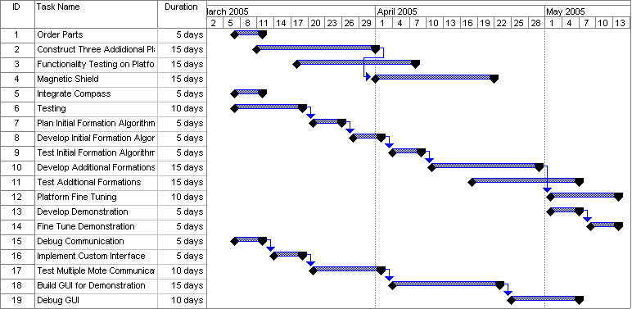
Figure 27 – Project Plan for Senior Design II

6.3 Budget

The prices below reflect the current pricing of components without shipping and handling. Since the products are being bought through RIT, tax does not apply. With the components listed below, each sensor platform will have two distance sensors, one compass, and two rechargeable batteries. The listed products will allow the project team to build three additional sensor platforms.

Part Name | Qty | Vendor | Price | Total
9.6V Rechargeable Battery | 4 | www.RCfinders.com | $8.99 | $35.96
Battery Charger | 1 | www.RCfinders.com | $26.99 | $26.99
Acrylite FF sheets | 3 | www.Jameco.com | $9.99 | $29.97
Ball Bearings | 1 | www.Jameco.com | $9.99 | $9.99
Tires | 6 | www.Jameco.com | $5.99 | $35.94
Stepper Motors | 6 | www.Jameco.com | $6.49 | $38.94
Devantech SRF04 Ranger | 6 | www.acroname.com | $36.00 | $216.00
R117-COMPASS | 3 | www.acroname.com | $51.00 | $153.00
UC3770 Motor Controller | 15 | www.digikey.com | $5.56 | $83.40
PIC18F4320 | 4 | www.digikey.com | $8.17 | $32.68
MAX233 | 5 | www.digikey.com | $3.17 | $15.85
Total Cost for Senior Design II |  |  |  | $678.72

7.0 Conclusion

The first six facets of the MERIT design process have been completed. The facets are the Needs Assessment, Project Objectives, Project Specifications, Concept Development, Feasibility Assessment, and Analysis and Synthesis of Design.
The mobile sensor platforms developed will be capable of entering a given formation topology through the use of environment sensing using sonar, communication using the Mica2Dot motes, and directional sensing using the compass chip. The software system installed upon the sensor platforms will be able to control and coordinate these individual aspects into a cohesive whole in order to successfully accomplish a task.
The concept development and feasibility assessment phases allowed the project group to brainstorm ideas, which ultimately led to a more robust design. The concepts developed were then assigned to different team members under the categories of Electronics and Sensors, Chassis Design, and Communication Implementation. Dividing up the tasks allowed group members to specialize in particular areas. Many options were explored implemented and discarded, improving the chassis design through three separate iterations.
During the requirements and design phases, the team examined the specifications to which the project must adhere and modified the concepts accordingly. A prototype chassis was laid out and built, allowing the functionality of all-important components to be tested. The mobile sensor platform that has been constructed meets the budget requirements for the quarter and meets the size and weight constraints placed upon the project by the sponsor.
Once testing and debugging of the initial design is completed next quarter, the main phase of the project will be able to commence – Implementation of formation topologies.

Appendices
A.1 Pinouts
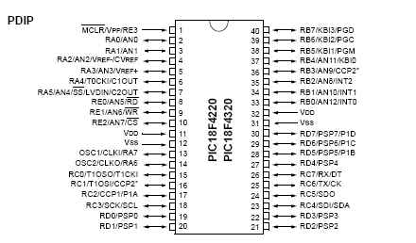

PIC18F4320 Microcontroller

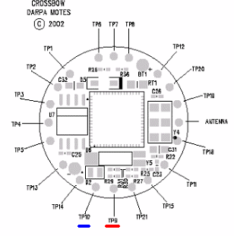
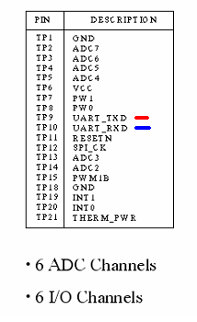

Mica2Dot Wireless Controller

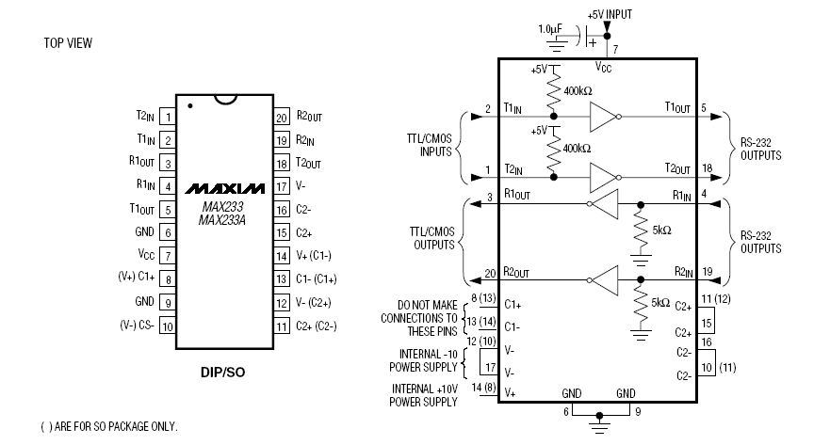
Max233 TTL to RS-232 Converter

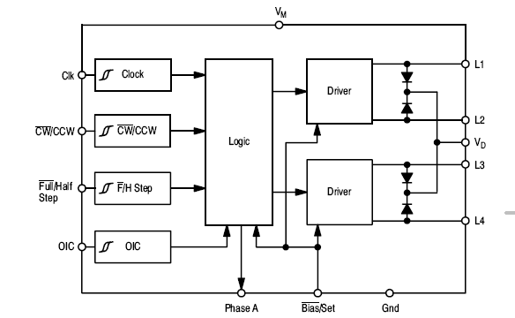
MC3479 Motor Controller

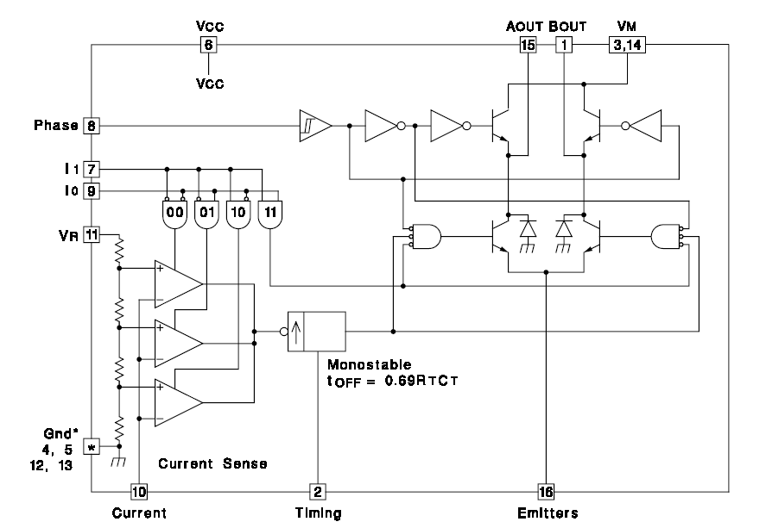
UC3770 Motor Controller

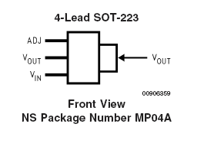
LM317T Voltage Regulator

