Speech Recognition Jukebox |  | ECE 476 SPRING 2007  FINAL PROJECT
Matthew Robbins and Arojit Saha
May 2, 2007
Table of Contents
Introduction
High Level Software Design
Capturing the Human Voice
Butterworth Digital Filters
Control Section
Audio Playback
Logical Structure
Hardware/Software Tradeoffs
Existing Patents and Trademarks
Program and Hardware Design
Program Design
Hardware Design
Microphone
High-Pass Filter
Low-Pass Filter
Non-Inverting Amplifier
Integration of Hardware Components
Television Circuit
Testing and Results
Conclusion
Appendices
Appendix 1
Appendix 2
Appendix 3
Appendix 4
Appendix 5

Introduction

For the Final Project in ECE 476: Designing with Microcontrollers, Robbins and Saha developed a Speech Recognition Jukebox, comprised of a speech recognition system that activated a simple music player. The speech recognition system was capable of recognizing four commands and could cycle through a simple play list of three songs. The jukebox could turn itself on, begin play, move between tracks, and stop play all through user voice commands.

In order to implement this design, Robbins and Saha needed to combine several different hardware and software elements. A small microphone was purchased and used to convert the human voice signal into a voltage signal. This alternating voltage signal was amplified by 1,000 times using three LM358 operational amplifiers. Hardware frequency filters were used to limit the frequency input and software frequency filters were used to parse the signal into different frequency regions.

The values of the signal in these different frequency regions helped to determine each individual word’s unique digital ‘fingerprint’. The fingerprints of important words, such as commands for the music-playing element of the design, were stored into the program. Each time a word was spoken, the fingerprint of this sample word was compared to the stored fingerprints to determine which command, if any, was spoken.

Recognized commands for the system are:

“ON” | Turn the music player on, play current song
“END” | Pause the music player
“SOON” | Play the next song
“PREV” | Play the previous song

Table 1: Voice Commands Recognized by the System

Given the correct combination of commands, a simple music tune would be played on the speaker of the television. A more in-depth analysis of the workings of both the software and hardware sections of the design can be found below.
Top of Page

High Level Software Design

Speech recognition systems have been implemented in a variety of different applications, most notably automated caller systems and security systems. These systems have progressed considerably in recent years and have the capability of performing numerous tasks from simple user vocal commands. For the ECE 476: Designing with Microcontrollers Final Project, Robbins and Saha’s ambition was to combine speech recognition technology with music playback. Robbins and Saha were inspired by the work of previous year’s groups, whose work is cited in Appendix 5, which demonstrated that such a project was realizable within the timing and hardware constraints of the ECE 476 Final Project parameters.

Capturing the Human Voice

The human hearing system is capable of capturing noise over a very wide frequency spectrum, from 20 Hz on the low frequency end to upwards of 20,000 Hz on the high frequency end. The human voice, however, does not have this kind of range. Typical frequencies for the human voice are on the order of 100 Hz to 2,000 Hz. Robbins and Saha would have hardware electrical filters that would pass only the frequencies between approximately 150 Hz and 1,500 Hz and several digital Butterworth filters that would work to parse this frequency spectrum into smaller regions. Both of these types of filters are discussed in more depth below.

But how often should one sample a signal that is oscillating at these frequencies? According to Nyquist Theory, the sampling rate should be twice as fast as the highest frequency of the signal, to ensure that there are at least 2 samples taken per signal period. Thus, the sampling rate of the program would have to be no less than 4,000 samples per second.

Also, the human voice moves a sound wave, which compresses and decompresses the air as it moves. As will be discussed below in the Hardware Design section, a microphone was utilized to convert this compression wave into an electrical signal that could be filtered, amplified, and analyzed.
Top of Page

Butterworth Digital Filters

The frequency spectrum of the human voice needed to be divided into several sub-intervals to allow analysis of the specific frequency spectrum of the word being spoken. Robbins and Saha divided the frequency spectrum into seven (7) intervals using six 4-pole Butterworth band-pass filters and one 2-pole Butterworth high-pass filter. The table below illustrates the scope of each filter:

Filter | Frequency Range
Band-Pass Filter #1 | 150 Hz – 350 Hz
Band-Pass Filter #2 | 350 Hz – 600 Hz
Band-Pass Filter #3 | 600 Hz – 850 Hz
Band-Pass Filter #4 | 850 Hz – 1100 Hz
Band-Pass Filter #5 | 1100 Hz – 1350 Hz
Band-Pass Filter #6 | 1350 Hz – 1600 Hz
High-Pass Filter | above 1600 Hz

Table 2: Frequency Range of Digital Filters

The Butterworth filter attempts to be linear and pass the input as close to unity as possible in the pass band. In the program design, the Butterworth filters manipulated the A/D converter output into the frequency domain. The code for both the high-pass Butterworth filter and the band-pass Butterworth filter were written by Bruce Land and can be found on the ECE 476 course website. The band pass Butterworth equation is as follows:

Equation 1: Band-Pass Butterworth Filter

The high pass Butterworth equation is as follows:

Equation 2: High-Pass Butterworth Filter

After deciding on the sub-intervals for the digital filters, Robbins and Saha wrote a MATLAB function to find the b1, a2, and a3 coefficients for all seven filters. The coefficients were found using the butter() function in MATLAB.

Top of Page

Control Section

The output of the digital filters would help to formulate a digital ‘fingerprint’ that was unique for each word. Five samples were taken from each digital filter, thus yielding 35 total samples that would comprise the digital fingerprint of each word. The fingerprints of the dictionary words, “ON”, “END”, “PREV”, “SOON”, were stored in the software program. Whenever the user input a command to the system, this sample’s digital fingerprint would be calculated and then compared to each of the dictionary words.

To compare the dictionary words with the sample, the program calculated the correlation of the two vectors. The pair with the highest absolute value correlation was chosen as a match. When an input command word was recognized as a dictionary word, the control section would set a series of flags that would update the state machine. This state machine would change state on these flags being set and each state corresponded to a separate song being played.

Top of Page

Audio Playback

Robbins and Saha chose three songs to be played by the jukebox - a Sonatina written by W.A. Mozart, “Ode to Joy” written by Ludwig van Beethoven, and the Star Spangled Banner. These songs were chosen because of their simple melody and easy recognition. Using the audio production code provided in Lab 4: Digital Oscilloscope, shown below, these songs notes were converted into a format that could be played on the television speaker.

Note | C | D | E | F | G | A | B | C | D | E | F | G | A | B | C | Rest
Value | 239 | 213 | 189 | 179 | 159 | 142 | 126 | 120 | 106 | 94 | 90 | 80 | 71 | 63 | 60 | 0

Table 3: Conversion Table for Musical Notes
(Bold C corresponds to middle C)
Top of Page

Logical Structure

The logical structure of the program is quite simple. The user will speak the desired command into the microphone. The microphone will convert this audio signal into an electrical signal, which will then be filtered and amplified before being sent to the A to D converter. The program A to D samples the input, and the output of the A to D converter is run through seven digital filters. The control section uses the outputs of the seven digital filters to obtain a working fingerprint of the spoken command and compares this fingerprint with those stored fingerprints to decipher which command, if any, has been spoken. Upon recognizing a user command, a state machine within the control section will change state. Each state of this state machine corresponds to a separate song being activated. Thus, upon changing state, a different song signal will be sent to the television audio connection, enable music playback. A simple schematic of the logical structure can be found below in Figure 1.

Figure 1: Logical Structure of Speech Recognition Jukebox

Top of Page

Hardware/Software Tradeoffs

To be able to execute all the commands in the program, there need to be enough clock cycles. The Mega32 clock runs at 16 MHz (16 million clock cycles per second). As the code requires that the A to D converter be sampled at a rate of 4 kHz, all the code for the program must be able to execute in 4,000 clock cycles (16 million / 4 kHz). Thus, the hardware must be able to work in real time and not further limit the capabilities of the program. As the hardware is mostly comprised of resistors and capacitors, and the LM358 is a relatively fast op-amp, there are no concerns with regard to hardware affecting the software.

The only constraint remains that all the computations performed by the program be able to fit it 4,000 clock cycles. The seven digital filters will consume the majority of the clock cycles. Each 4-pole band-pass Butterworth filter takes up 228 clock cycles and the 2-pole high-pass Butterworth filter takes up 148 cycles. Thus, all the filters together will consume 1,516 cycles. This yields almost 2,500 clock cycles for the remainder of the code, which is more than enough space.

Top of Page

Existing Patents and Trademarks

Several phone and technology companies, notably AT&T and Microsoft, have patented speech recognition technology. Robbins and Saha do not believe that their design will infringe the rights of these companies’ patents as it will a unique, novel and non-obvious approach to speech recognition using original hardware and software design.
Top of Page

Program and Hardware Design

Program Design

The dataflow of the program begins with the output of the A/D converter. This value is stored in the variable Atemp. Atemp is set in the Timer/Counter 1 interrupt, which runs every 250 μs (4,000 times per second). Atemp is then passed to the seven digital Butterworth filters using a function called setfilters(), which is also run in the interrupt. After the filters have been set, the program enters the player() function, which contains the state machine that runs the voice recognition section of our program.

The player() function is broken up into six states: TAKE, WAIT1, ON, END, AFTER, LAST. The TAKE state is considered to be the off state of the jukebox. When button 7 is pressed on the STK500 board, the player turns on. The user will have to press button 6 to use the voice recognition portion of the state machine. Upon this button being pressed, the state machine is in the WAIT1 state. In this state, the state machine is waiting for the user to say the word “ON.” This signals to the state machine that the user wishes to start the player. After the user says “ON,” the state machine enters the ON state and begins playing song 1 (“Ode to Joy”).

Once in the ON state, the voice recognition state machine has four possible routes. If the user says “SOON,” the state machine assumes the user wants to play the next song (song 2). If the user says “PREV,” the state machine assumes the user wants to play the previous song (song 3). The user can also say “END,” indicating the user wants to pause the playback of the song. Based on whether the user says “SOON”, “PREV”, or “END”, the player state machine enters the AFTER, LAST, or END states, respectively.

In the AFTER state, the state machine plays song 2. If the user says “SOON”, the state machine enters the LAST state and plays song 3. If the user says “PREV”, the state machine enters the ON state and plays song 1. In the LAST state, the state machine plays song 3. If the user says “SOON”, the state machine plays enters the ON state and plays song 1. If the user says “PREV”, the state machine enters the AFTER state and plays song 2. If at any time button 7 is pressed, the state machine goes back to the TAKE state and the player has been turned off. A diagram of this state machine is found below.
TAKE
WAIT
ON
END
AFTER
LAST

Figure 2: Diagram of player() state machine

In the player() state machine, the voice recognition system is always running. The samples coming in from the Butterworth filters are compared to a set of dictionary fingerprints. A correlation function is run to see which dictionary fingerprint most corresponds to the sample. Whichever dictionary fingerprint produces the highest (closest to 1) absolute value is most similar to the word being spoken by the user. This section involved the most debugging of our program. Initially, we had the user input in various dictionary definitions at the start of the player() state machine.

However, every sample is different and consistency could not ensured every time the program was run. For this reason, Robbins and Saha created a different program that saves words and outputs these words in the Hyperterm terminal. This program was used to create dictionary fingerprints and to store them in SRAM. Robbins and Saha took two samples each for every dictionary word. The inspiration for this idea came from the Voice Controlled Car from the Spring 2006 semester of ECE 476, whose code is referenced in the Appendices.

Another problem with the system that required considerable debugging was that initially Robbins and Saha used Euclidean distances to relate samples to dictionary fingerprints. However, this approach was fairly inconsistent and did not work often enough to be useful. This inconsistency was due to the variation between samples. While looking through the Spring 2006 semester of ECE 476, Robbins and Saha saw the Voice Recognition Security System used correlation to relate samples to dictionary fingerprints and had a increase in recognition rate. This group’s code is also referenced in the Appendices.

Based on their design, Robbins and Saha decided to try correlation and had an increase in recognition rate. This approach was proven to be more successful thanks to outputting the state of the player() state machine to the Hyperterm terminal after a sample was spoken. Robbins and Saha also had problems with recognition of certain words over other words. Several words were tried before deciding on the final list including, “NEXT”, “AFTER”, “STOP”, and “PAUSE”.

Top of Page

Hardware Design

As mentioned above in the High Level Software Design section, the human voice is comprised of numerous different frequencies emitted as a compression wave through the air. In order to perform analysis on a vocal sample, this compression wave would need to be transformed into an electrical signal using a microphone. The electrical output of the microphone was filtered and amplified several times in order to produce a clean and responsive voltage signal. Each of the separate hardware components used to perform these tasks is discussed individually below, followed by a discussion of each section’s integration and specific design choices made by Robbins and Saha.

Microphone Circuit

Microphone

To convert the human voice compression wave to a voltage signal, Robbins and Saha used a microphone purchased a small microphone (Part# 423-1027-ND) from the Digi-Key Corporation. This microphone’s ground and output connections needed to be soldered to the white board and the output was then filtered using a high-pass filter. As can be seen on the data sheet, this specific microphone had an operating frequency range of 300 Hz to 6,000 Hz, which is an appropriate frequency range for measuring the human voice. However, the signal produced by the microphone was so small that it needed to be amplified considerably and is discussed below in the integration section. Schematics of the connections of the microphone and its circuit connections can be found below.

Figure 3: Schematic of Digi-Key Part #423-1027-ND Microphone

Figure 4: Schematic of Connections and High-Pass Filter

Top of Page

High-Pass Filter

A high-pass filter is designed to pass all frequencies above a predetermined cutoff frequency (f_{cHP}) and to attenuate any frequencies below this cutoff frequency. Below the cutoff frequency, the output of a high-pass filter will decrease by -20dB/decade, or by a factor of 10 for every order of magnitude decrease in frequency. For a passive resistor, the cutoff frequency is determined by the values of the resistor and capacitor used. The cutoff frequency is related to the resistor and capacitor values by the following formula:

Equation 3: Cutoff Frequency of High-Pass Filter

In order to achieve the desired filtering result, the resistor and capacitor must be arranged as shown in the figure below:

Figure 5: Circuit Schematic of High-Pass Filter

Top of Page

Low-Pass Filter

A low-pass filter is designed to pass all frequencies below a predetermined cutoff frequency (f_{cLP}) and to attenuate any frequencies above this cutoff frequency. Above the cutoff frequency, the output of a low-pass filter will decrease by -20dB/decade, or by a factor of 10 for every order of magnitude increase in frequency. For a passive resistor, the cutoff frequency is determined by the values of the resistor and capacitor used. The cutoff frequency is related to the resistor and capacitor values by the following formula:

Equation 4: Cutoff Frequency for Low-Pass Filter

In order to achieve the desired filtering result, the resistor and capacitor must be arranged as shown in the figure below:

Figure 6: Circuit Schematic of Low-Pass Filter

Top of Page

Non-Inverting Amplifier

The non-inverting amplifier is a three-port circuit, with two input ports and one output port. The two input ports, labeled (–) and (+) on the circuit diagram below, are referred to as the non-inverting and inverting inputs, respectively. The inverting input is connected to ground through a resistor and the non-inverting input is connected to the signal to be amplified. By utilizing a feedback resistor between the inverting input and the output, the input signal to the non-inverting input will be amplified.

The feedback resistor (R_{f}) and the grounded resistor (R_{in}) form a voltage divider with the feedback voltage. The feedback voltage can be written as follows:

Equation 5: Relationship of input and feedback voltage for a Non-inverting Amplifier

The gain of this circuit, expressed as V_{out}/V_{in}, can be expressed as (R_{f} + R_{in})/ R_{in}, or R_{f} / R_{in} + 1. The resistor connected to the non-inverting input (R⁺) has no effect on the gain of the circuit. The circuit connections for a non-inverting amplifier can be found below.

Figure 7: Circuit Schematic of Non-Inverting Amplifier

Top of Page

Integration of Hardware Components

A white board was used to connect and integrate all the separate components of the hardware section of the project.

In order to operate properly, the ground and output connections on the microphone needed to be soldered to two pieces of wire and then connected to the white board. This output connection was connected to a high-pass filter with a 1 kΩ resistor and 1 μF capacitor, giving this filter a cutoff frequency 159 Hz. This cutoff frequency is low enough that almost all frequencies of human speech were able to pass through to the rest of the circuit. The value of this cutoff frequency was important because it ensures that the 60 Hz electrical noise was not included in the circuit.

The voltage signal produced by the microphone was an alternating voltage (AC). However, this AC signal was very small and needed considerable amplification to be recognized by the Analog to Digital (A to D) converter. The microcontroller’s A to D converter, discussed above in the software section, was set to assign an output value from 0 to 255 for input voltage values between 0 V to 5 V, with output value 0 corresponding to input voltage 0 V. Each unit increase of the A to D converter corresponds to approximately 20 mV, meaning that the fluctuation of the microphone voltage signal needed to be at least this large in order to be noticed by the A to D converter. Upon inspection, an amplification factor of 1,000 was most suitable for this voltage signal. Robbins and Saha used three LM358 operational amplifiers (“op-amps”) to amplify the signal, with each op-amp amplifying the signal by a factor of 10.

It is important to note here that the LM358 op-amp is not a rail-to-rail amplifier. It’s lower rail is 0 V and its upper rail is 3 V, meaning it will not output a voltage signal above 3 V. To accommodate this design constriction, the non-inverting input to the op-amp was set to 1.6 V, about halfway in-between the op-amp’s rails, by using a 2 kΩ and a 1 kΩ resistor voltage divider. While testing the amplifier setup, Robbins and Saha noticed that the amplifier amplified both the AC and DC components of the signal, thus it was necessary to block the DC component of the signal using a capacitor, otherwise the output would be on the order of 10*1.6V, which would have been above the output capabilities of the op-amp. To ensure that only AC signal reached the non-inverting input of the op-amp, a 1 μF capacitor was connected to the voltage divider.

The input of the op-amp also acted as another high-pass filter. The resistive component of the filter is the Thevenin equivalent resistance of the 1 kΩ and 2 kΩ resistors in parallel, 666 ohm. Using a 1 μF capacitor, the cutoff frequency of this high-pass filter is 239 Hz, which was low enough that almost all frequencies of human speech were able to pass through the circuit.

To create a 10x voltage amplifier, a 10 kΩ and a 1 kΩ resistor were used in the non-inverting amplifier set up described above yielding a gain of 11, which is approximately 10. Also, to ensure that only the AC signal gets amplified, a 1 μF capacitor was connected from the 1 kΩ to ground.

This same amplifier arrangement was repeated three times to enable the signal to be amplified by a factor of 1,000.

While testing the output of the microphone on the oscilloscope, Robbins and Saha noticed a considerable amount of high-frequency noise prevalent in the circuit. To attenuate this unwanted noise, a low-pass filter was added to filter out this high-frequency noise. A 1 kΩ resistor and .1 μF capacitor were used to give the filter a cutoff frequency of 1,591 Hz. This cutoff frequency was high enough that almost all frequencies of human speech were able to pass through the circuit. Upon making this adjustment to the circuit, the output of the microphone was a very clean signal and responded well to any vocal or other audio input, as verified by the oscilloscope. Below are a circuit schematic for the microphone circuit and a picture of the actual one used by Robbins and Saha.

Figure 8: Overall Schematic of Microphone Circuit
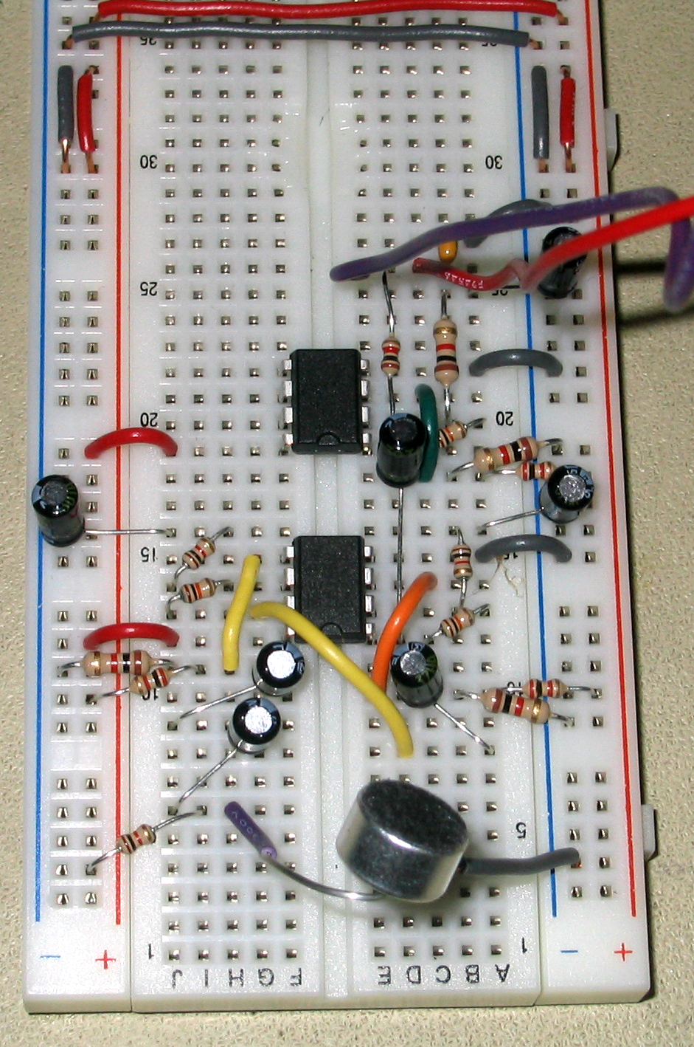

Figure 9: Picture of Microphone Circuit on White Board

Top of Page

Television Circuit

The circuitry for the television circuit was far simpler. The output for the audio was set as the PORTB.3 output pin. This output was connected to ground using a 10 kΩ resistor. A coaxial cable was connected to the PORTB.3 output pin and properly grounded. This coaxial cable served as the connection to the audio input in the back of the television. The television was set to TV mode and powered on. With proper circuitry, the tunes played by the jukebox were clearly audible. A picture of the television used in the audio playback section of the jukebox is found below.

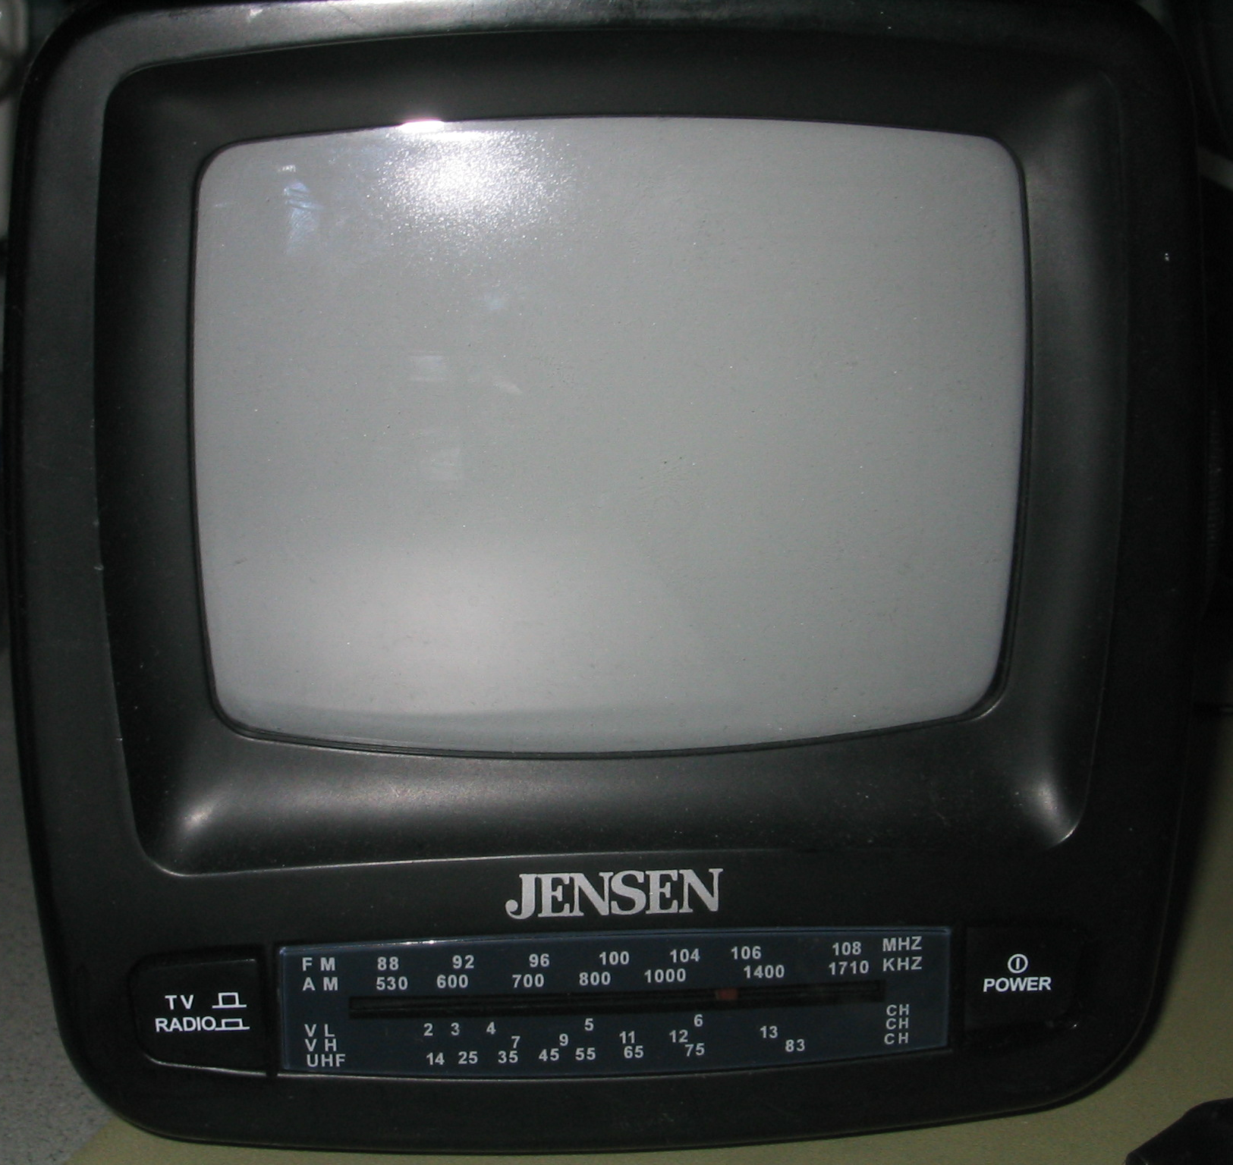

Figure 10: Picture of Television used for Audio Playback

Top of Page

Testing and Results

The Speech Recognition Jukebox worked. Upon prompting it with the correct series of commands, the television audio speaker played the songs that were supposed to play and in the correct order. The speech recognition system did not always recognize command words, but after several repetitions, it would proceed to the correct state and play the correct song. Erroneous words were input into the system and were ignored, as is consistent with the design specifications. The speech recognition algorithm used in the program was simpler than commercial algorithms. Due to concerns regarding the capacity of the Mega32 microcontroller, these more complex algorithms were not used in the project design.

The music played was rough, but clearly recognizable as these popular songs. The Hyperterm terminal was kept open and updated as the state changes, and the LEDs on the STK500 board also provided feedback as to the correct functioning of the system. The system was disrupted occasionally by background noise in the lab. A laugh, cough, or other noise in the lab would sometimes affect the performance of the system.

There were no threatening safety concerns with the project. Both the microphone and television circuit were low power and had no moving parts.

The Speech Recognition Jukebox was coded for the voices of Robbins and Saha and worked well for these users. A fairly easy process could be used to incorporate any other user’s voice.

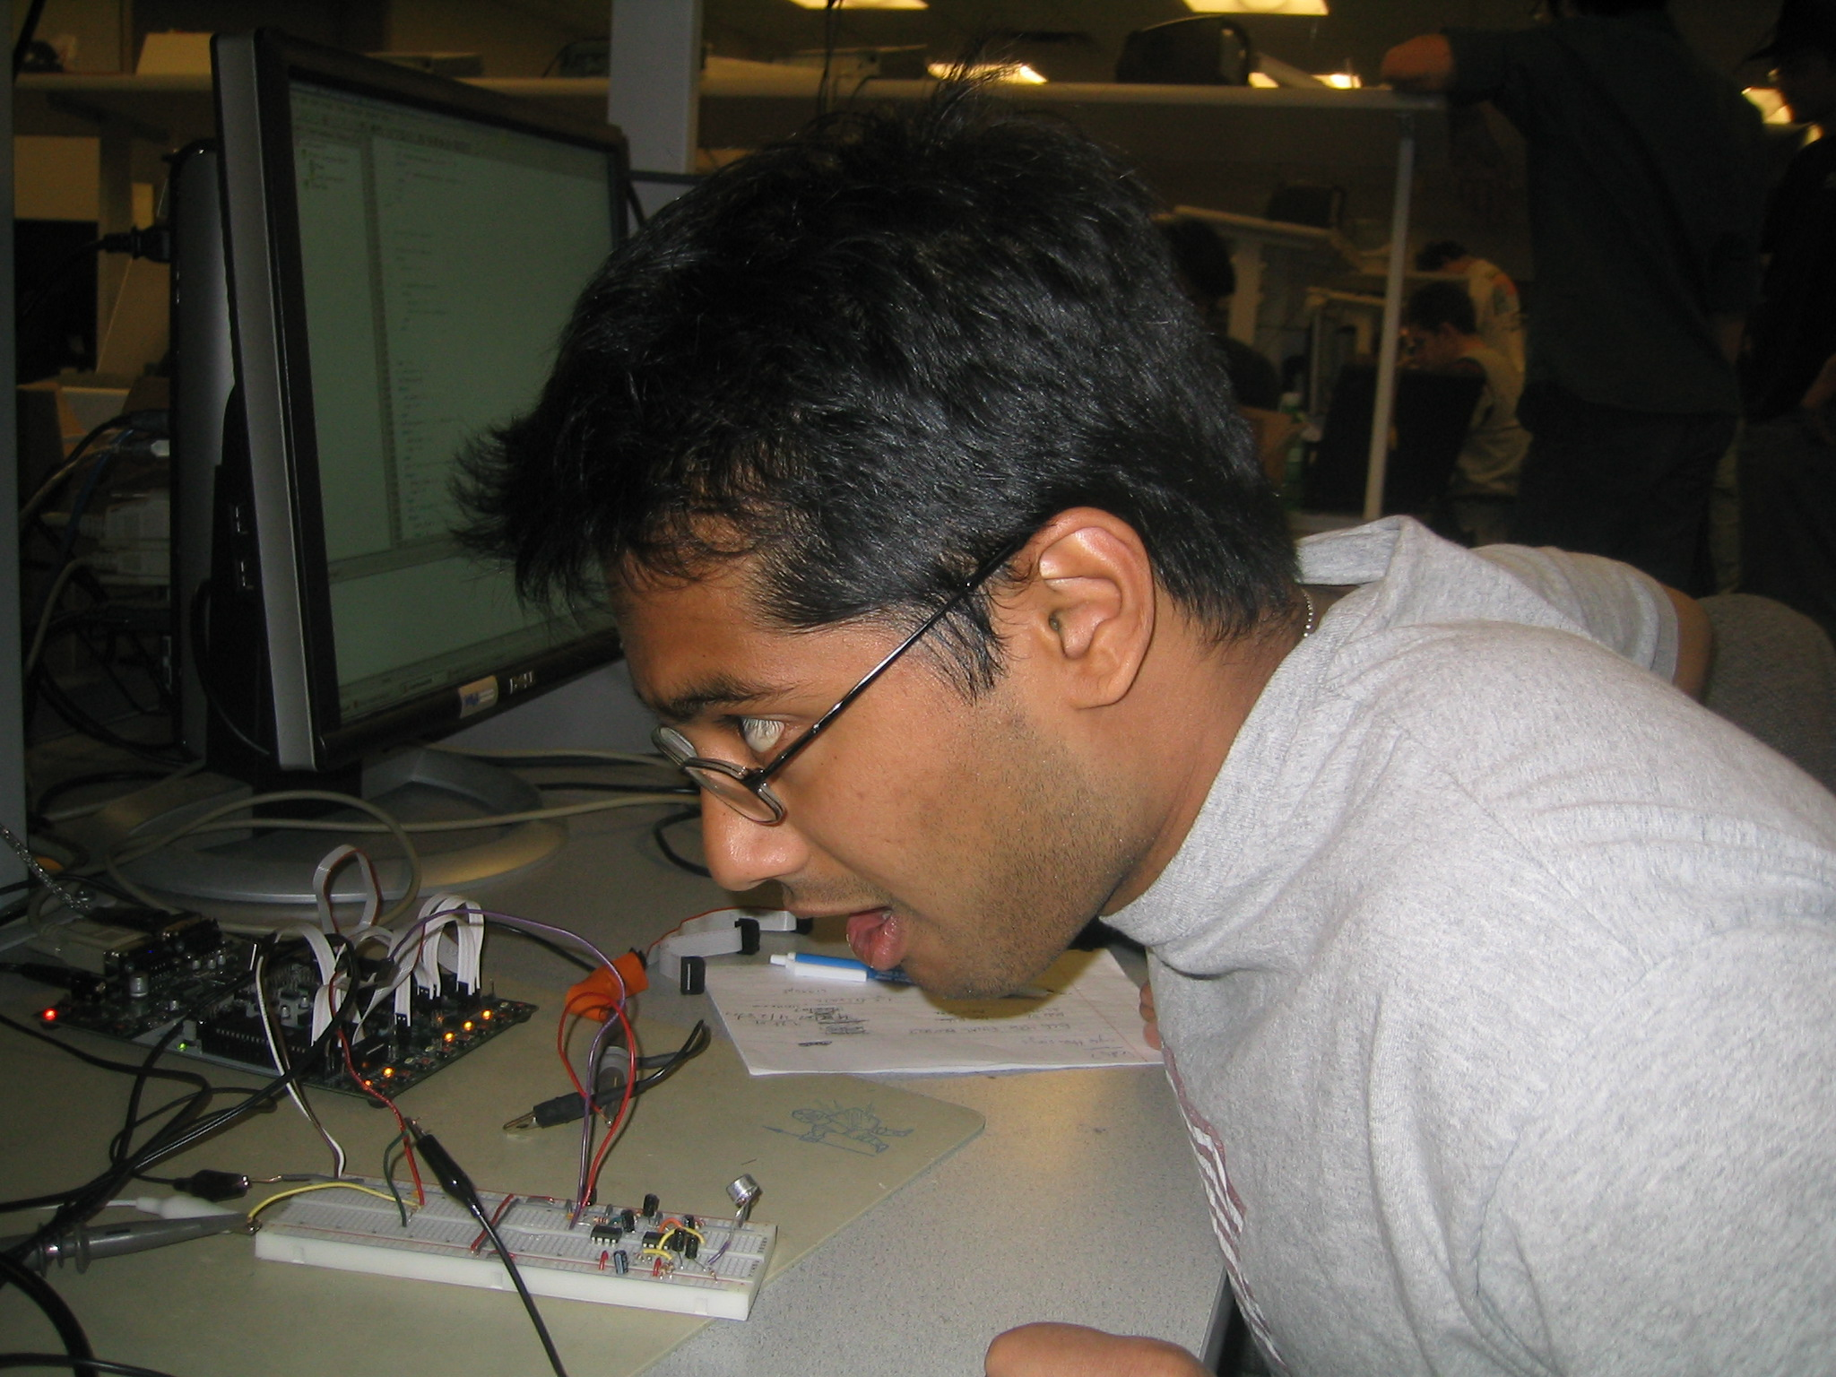

Figure 11: Arojit Saha testing the Speech Recognition System

Top of Page

Conclusion

Hours of coding and debugging resulted in a design that recognized several key input commands and played music on the television audio speaker. In this regard, the program was a success. However, when initially proposing the project idea, Robbins and Saha had hoped to be able to incorporate a more elaborate play list with more specific commands, such as a volume option. The speech recognition portion of the program took far longer than anticipated as the algorithms needed to identify which words were being spoken took considerable effort to perfect and were not well conceived until later in the project. Given the opportunity to complete the project again, Robbins and Saha would have dedicated more time and thought towards the speech recognition algorithm design earlier in the project, which would have enabled more options to be included in the later weeks of the project.

The Speech Recognition Jukebox required Robbins and Saha to incorporate knowledge learned in several ECE courses taken by both students. To develop the hardware circuit, they needed to use circuitry design skills developed in ECE 210 and ECE 315. To work with the frequency spectrum of speech and the digital filter design, the students needed to use skills learned in ECE 220. In order to manipulate the assembly code and C code, the students depended on skills they learned in ENGRD 230 and ECE 314. The incorporation of these separate topics and the complexity of the design of the program demonstrate that the project was the appropriate level of hardware/software complexity.

The project worked to the specifications set by Robbins and Saha. To make the program work to these specifications, Robbins and Saha needed to use almost all of the time allotted for the final project. All materials for the lab, including those purchased from external vendors, totaled only $41.36, which was below the budget of $50 set for the lab. A detailed cost and itemized expenses breakdown can be found in the Appendices.

The only intellectual property considerations to consider are the patents surrounding speech recognition. Several phone and technology companies, including AT&T and Microsoft, have speech recognition patents. However, Robbins and Saha developed their speech recognition program independent of any designs specified in these patents. This unique and novel design would make it possible for Robbins and Saha to patent their design. It is important to note that Robbins and Saha used code provided by Professor Bruce Land for the digital filter design and referenced code provided by previous groups for help in debugging the speech recognition algorithm of the project.

In accordance with the IEEE Code of Ethics, Robbins and Saha made several design decisions. Robbins and Saha accept all responsibility of any consequences of design choices during the creation and testing of the ECE 476 Final Project. Although no severe safety issues or environmental issues exist with the current design, should any arise, it is our responsibility to disclose these finding to the public. No conflicts of interest exist and should they arise, we will disclose those issues to the affected parties. Robbins and Saha were honest and realistic in all claims and estimates based on available data and did not engage in any questionable moral practices with regards to bribery or coercion. The aim of the project was to gain a better understanding of programming with microcontrollers, as that was the goal of this course, but also to further the understanding of speech recognition technology and be able to pass this knowledge on to subsequent classes through the use of the course website. Any honest criticism of the work performed by Robbins and Saha is encouraged and greatly appreciated. This feedback will only help to further our knowledge and understanding of this subject. Robbins and Saha do not discriminate or judge people based one race, religion or any other factors and avoid at all costs any injuries inflicted upon others. Robbins and Saha are pleased that they were able to complete this project in the allotted time and were given the chance to give back to the ECE 476 community through the course website and the posting of this final lab report.
Top of Page

Appendices

Appendix 1 - Commented Final Code

Voice Recognition Jukebox Final Code

Appendix 2 - Circuit Schematics

Figure 12: Overall Schematic of Microphone Circuit

Figure 13: Picture of Microphone Circuit on White Board

Top of Page

Appendix 3 - Costs and Itemized Expenses of Project

Item | Unit Cost | # Used | Cost
Atmel Mega32 Microcontroller | $8.00 | 1 | $8.00
White board | $6.00 | 1 | $6.00
STK 500 board | $15.00 | 1 | $15.00
Power Supply | $5.00 | 1 | $5.00
Digi-Key Microphone #423-1027-ND Manufacturer Part #MD9752NSZ-0 | $2.36 | 1 | $2.36
Black and White Television | $5.00 | 1 | $5.00
LM358 Operational Amplifier | $0.00 | 2 | $0.00
Resistors
1 kΩ | $0.00 | 8 | $0.00
2 kΩ | $0.00 | 3 | $0.00
10 kΩ | $0.00 | 4 | $0.00
Capacitors
1 μF | $0.00 | 7 | $0.00
.1 μF | $0.00 | 1 | $0.00
Total Project Cost |  |  | $41.36

Table 4: Costs and Itemized Expenses of Project

Appendix 4 - Division of Project Tasks

Project Task | Member Responsible
Software | Robbins and Saha
Digital Filter Design | Saha
Control Section | Robbins and Saha
Audio Playback | Robbins and Saha
Debugging | Robbins and Saha
Testing | Robbins and Saha
Hardware | Robbins and Saha
Microphone Connection | Saha
Filter Design | Robbins
Amplifier Design | Robbins
Television Connection | Robbins
Project Research | Robbins and Saha
Lab Report | Robbins and Saha

Table 5: Division of Project Tasks
(Bold indicates group member primarily responsible)

Top of Page

Appendix 5 - References used

Data sheets

LM358 Operational Amplifier
Digi-Key Microphone Part# 423-1027-ND
Mega32 Microcontroller

Vendor sites

Digi-Key Corporation

Code/designs borrowed from others

ECE 476: Designing with Microcontrollers website
Prof. Land’s 2-pole Butterworth Filter code
Prof. Land’s 4-pole Butterworth Filter code
Tor's Speech Recognition reference code
Spring 2006 Voice Recognition Security System
Spring 2006 Voice Recognition Robotic Car
Top of Page

