Digital Oscilloscope
ECE 4760 Final Project
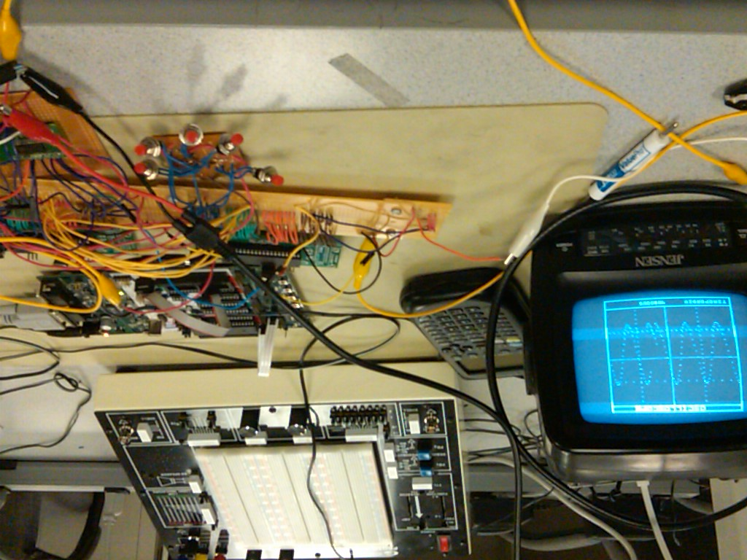
Emily McAdams, egm23
Luke Diamente, lad97
Richard Wu, rsw35
Introduction 2
High Level Design 3
Background Math 3
Logical Structure 4
Patent, Copyright and Trademark Concerns 4
Hardware Design 5
Level Shifter and Amplifier 5
Microcontroller Boards and Microcontrollers 5
Digital to Analog Converter 6
Analog to Digital Converter 7
Other Hardware 8
Software Design 8
Data Acquisition 8
Video Generation 10
Testing 11
Hardware Testing 11
Software Testing 11
Results 14
Safety 14
Usability 14
Accuracy 14
Conclusion 15
Intellectual Property Considerations 15
Ethical and legal considerations 16
Appendices 16
A. Datasheets 16
B. Budget 16
C. Commented Code Listing 17
D. Schematic 17
E. Division of Labor 17
F. Special Thanks 17

Introduction
The goal of our project is to design a digital oscilloscope with 20 kHz bandwidth. The scopes that we use in ECE 4760 lab cost over one thousand dollars. The motivation of our project is to produce an affordable, easy to make oscilloscope for students or other engineers who cannot afford to buy a manufacturer’s oscilloscope. We are aiming for a range of up to 20 kHz and the waveform is displayed on a 5 inch black and white television. Two microcontrollers are used to store and print data onto the screen.

High Level Design
Oscilloscopes are very versatile pieces of electronic test equipment that are used in a wide variety of applications. For example, heart beat patterns can be displayed on a specialized type of oscilloscope called an electrocardiogram. With all these uses, we decided that it would be interesting to build our own 200 kHz digital oscilloscope. This project presents difficulty in both hardware and software design. Having a solid understanding of how this tool works will be essential for our future as electrical engineers.

Background Math
This project relies on sampling a waveform and then reconstructing it. The Shannon sampling theorem, which states that samples must be taken at a rate greater than twice the maximum frequency of the original signal (or at the Nyquist rate), is used so that no aliasing occurs. Aliasing occurs when a signal gets undersampled; a waveform of lower frequency will get reconstructed instead of the correct higher frequency signal. A picture is shown below to illustrate the idea:
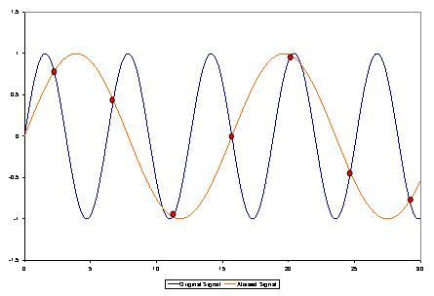
http://commons.wikimedia.org/wiki/Aliasing
The undersampled waveform will have a frequency of:
f_{alias} = f_{sample-rate} – f_{original-signal}
Therefore, in this project, the sampling rate is always set higher than 40 kHz (the oscilloscope functions correctly at a maximum frequency of 20 kHz). The A-to-D converter is responsible for sampling and has a maximum sampling rate of 2 megasamples/sec.

Logical Structure
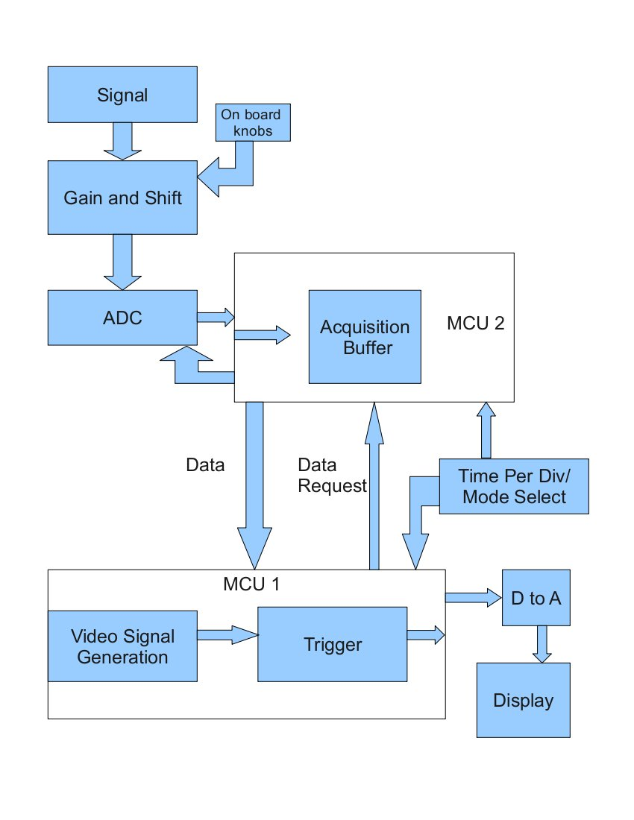
Figure 1: High level diagram

The analog circuits on our board simply adjust the amplitude and level of the input signal using standard op amp circuits. Depending on which time per div has been selected, MCU2 acquires data at a specific number of samples per second as determined by a timer. These samples are stored into the data buffer. Once it is filled no new data can be stored until all of the points in the buffer have been drawn. Also depending on the time per div selected, MCU1 will request a certain number of data points per frame and draw these on the screen. For very high frequencies it will draw many points per frame to appear more 'real time.' Once MCU1 has drawn every point in the buffer MCU2 is free to start filling the buffer up again. This cycle continues indefinitely until the time per div is changed and the cycle then begins again.

Patent, Copyright and Trademark Concerns
The project uses some patented components as subcomponents. However, there is no patent limitation on our final design as we are using the devices as the manufacturer intended.

Hardware Design

Level Shifter and Amplifier
The signal to be displayed is applied to the 100k resistor of the lower op amp. The potentiometer can be adjusted to change the amplitude of the signal. The output goes into a capacitor to remove any DC level and the resistive divider sets a new DC level for the signal. The top op amp is designed to have an output from 0-5V. The two signals feed into a summing amplifier which adds the adjustable DC signal to the fixed level, variable gain input signal. The output of this op amp goes straight into the ADC.
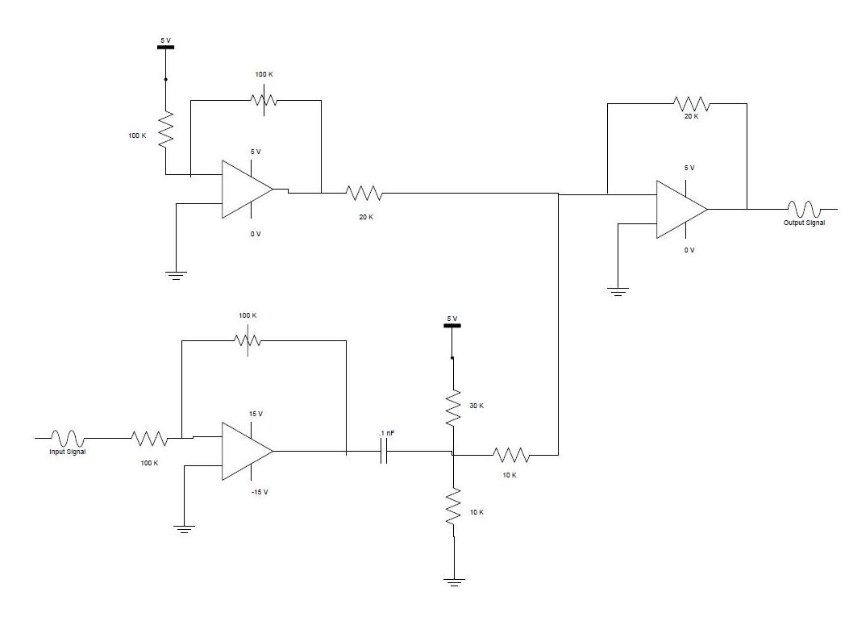
Figure 2: Schematic of proposed level shifter and amplifier

Microcontroller Boards and Microcontrollers
In order to achieve our bandwidth goals for the oscilloscope we had to use two Atmel Mega644 microcontrollers. In order to use the microcontrollers without the STK500s we had to build the custom PC boards designed by Bruce Land for 4760. In addition to the microcontrollers, the hardware we used on the board was a DIP socket, six pin headers for the flash programmer, resistors and capacitors, a voltage regulator, an LED, and a 16 MHz crystal. We did not need serial communication for our project so we omitted the MAX233 and serial connection port.
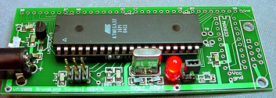
Figure 3: Populated prototype board designed by Bruce Land

Digital to Analog Converter
The video signal and sync signal were sent to the TV via port pins D.5 and D.6 respectively. A voltage of 0.3 V corresponded to a black pixel, while a voltage of approximately 1.1 V corresponded to a white pixel. The sync signal was a 0V signal. A sync pulse lasting 180 µs signaled the start of a new frame, and a sync pulse lasting only 5 µs signaled the start of a new line. We got the design for this DAC from ECE 4760 Lab 3.
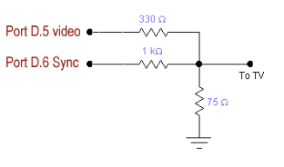
Figure 4: Schematic of Digital to Analog converter

Analog to Digital Converter
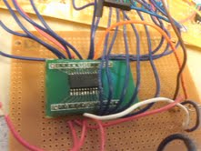
Figure 5: AD7825 in SOIC package
In order to achieve the sampling rates needed to display the full range we want to for this project we needed an external ADC. The Analog to Digital converter we used is the AD7825 from Analog Devices. It is an 8-bit half-flash with 420 ns of conversion time. Its maximum sample rate is 2 Megasamples per second. The ADC works with signals in a voltage range from 0 V to 2.5 V when powered by a 5 V power supply. Since the ADC is the only external chip we are working with we leave the Chip Select signal low to always have the chip selected and the Power Down signal high to keep the ADC turned on. The ADC begins a conversion when the CONVST signal goes from high to low. This signal may only stay low for a maximum of 120 ns, otherwise the ADC will go into power down mode. When the conversion has finished, the EOC signal from the ADC to the microcontroller (which is hooked up to an external interrupt) goes low to trigger the interrupt. Once the microcontroller sets the read bit low, the data from the ADC is valid and the ISR can read data into the buffer. The read bit must be sent back to high in order to reset the EOC signal. Another conversion cannot start until at least 30 ns after the read has been set back to high. Considering that the maximum clock rate for our MCU is 62.5 ns this is not a limitation we had to deal with.
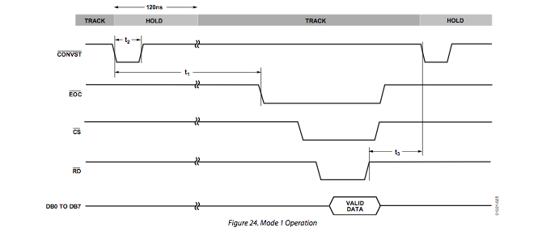
Figure 6: Timing diagram from AD7825 datasheet

Other Hardware
Other hardware we used in our design included a Black and White Jenson TV with analog input and five push buttons used to control the time per division of our project.

Software Design
This project included two microcontrollers in order to get the desired sampling rate and successfully display the video. Therefore, we had to write a separate code file for each microcontroller. One code file, named scope_calc.c, receives data from the external ADC and transmits it to the other microcontroller. The other piece of code, scope_video.c, handles receiving data from the other microcontroller, setting up the data for display, and outputting the video signal to the black and white TV. The fact that the MCU handling the video output is constrained to a very specific timer and can have no other interrupts running is the reason we need the second board.

Data Acquisition
This piece of code is on the board responsible for communication with the ADC and sending the data to the video board on request. This code has five main portions: initialization, main(), INT0 ISR, INT1 ISR, and Timer0 compare match ISR. The initialization first sets up all the ports that will be used in the program. Port A is set up as input pins for Data from the ADC, Port B is also initialized as input for connections to the push buttons. Port C is initialized to output and it is used for sending data to the other board. Finally, 6 pins on Port D are set up to be output pins used to configure the ADC and two are used as inputs for external interrupts.

 | Input/Output | Assignment | Functionality
D.0 | Output | ADC Channel Select (A0) | Always 0
D.1 | Output | ADC Channel Select (A1) | Always 0
D.2 | Input | ADC EOC | INT0 ISR triggered on falling edge
D.3 | Input | Port C.0 on Video MCU | INT1 ISR triggered on falling edge
D.4 | Output | ADC Power Down | Always 1
D.5 | Output | ADC Read | Read Data from ADC when low
D.6 | Output | ADC Chip Select | Always 0
D.7 | Output | ADC Convert Start | 1->0->1 to start a conversion
Figure 7: Table with pin assignments for ADC communication

Initialization also enables both external interrupts and sets them to trigger on the falling edge of the signal. We chose falling edge because that is how the ADC we use functions. (May adjust one to trigger on both edges – speed up our display time – would fix our problem with displaying multiple points at once). Finally, timer 0 is set up in the initialization. It is initially set to run at a low sampling speed, for the lowest range of frequencies. The compare match interrupt is enabled on this timer so it interrupts when the timer reaches the value set in OCR0A.
The next part of the scope_calc code is the main loop. The only thing in that happens in this loop is that the push buttons are checked. The buttons are not debounced, but for this particular application it does not matter. The buttons determine what range of frequencies can be displayed on the screen. If a button is a pushed the clock prescalar and the value of OCR0A are adjusted accordingly.

Push Button # | Port Connection | TCCR0B | OCR0A | Frequency Range
1 | B0 | 5 | 128 | 1 Hz – 10 Hz
2 | B1 | 5 | 25 | 10 Hz – 100 Hz
3 | B2 | 4 | 10 | 100 Hz – 800 Hz
4 | B3 | 2 | 35 | 800 Hz – 5 kHz
5 | B4 | 1 | 10 | 5 kHz – 20 kHz
Figure 8: Table with prescalar and OCR0A assignments
External interrupt INT0 is Pin D.2 on the microcontroller. The signal from the ADC which indicates that a conversion has finished is attached to this pin. The ADC signal, EOC, goes low when a conversion is finished, so the interrupt is set to trigger on the falling edge of the signal. When the INT0 ISR executes it begins by setting the value of D.5 (Read) to low to initiate a read. It then checks the value of a variable named “lock.” If lock is low, then no data is stored in the data buffer. Using “lock” controls whether or not data is read/written into the data buffer. The ADC can convert data much faster than the video MCU can read it out, so in order to control the data going to the video board, the buffer must lock once it fills up until the video code reads out the rest of the buffer. If lock is 0, then the data from the ADC is stored into the buffer at 'inc.' 'Inc' is then incremented and it is checked whether or not inc reaches the bounds of the buffer. If so, lock is set to 1 and inc is reset to 0. At the end of the ISR, read is set back to high. This interrupt will only trigger once a conversion is ended and the rate of conversion starts is determined by the clock prescalar and the value of OCR0A.

External interrupt INT1 is Pin D.3 on the microcontroller. The signal from the video board indicates that the video board is ready to read a byte of data stored in the data buffer. When the interrupt is triggered the ISR puts a byte of data onto PORT C to be read by the video board. It takes the byte of data in the buffer at the increment 'video_inc.' It then increments the value and checks if the value of 'video_inc' has exceeded the buffer size. If it has, then video_inc and lock are both set back to zero.

The final component of the scope_calc.c code is the ISR triggered by the Timer 0 compare match vector. The scalar of the timer and the value of OCR0A is changed by the push buttons and determines the sampling rate. When this ISR triggers it sets the value of D.7 (CONVST) to 0 and then back to 1 in order to trigger an interrupt. Its important that D.7 stays 0 for less than 130 ns or else the entire ADC will power down.

Video Generation
The purpose of this board is to generate the oscilloscope's display onto the black and white television. The signal generated must result in a frame being exactly 1/60 sec in order to conform to the NTSC standards. All of the code to generate the actual signal is adapted from code provided by the ECE 4760 staff for Lab 3. The screen’s vertical number of lines is 262, however only lines 30 – 230 are visible on the television screen. Every 1018 ticks of the clock, the timer’s ISR would either perform synchronization tasks or actually print onto screen using the byteblast() function. Byteblast() calls an assembly macro named videobits to print the individual bytes to screen. Since the program is not outputting anything to the screen during lines 231 to 262 and 0 to 29, this is where we do all of the updates to the video screen. During this time the program checks the status of the push buttons, requests and reads data from the calculation board, and writes all of the information to be displayed to the screen in the next frame.
In the initialization of the code, Port A is set up as input to read a byte of data from the calculation board, Port B is initialized as inputs to read the push buttons, Port C0 is set up as an output port and its signal is used to trigger INT1 on the other microcontroller, and finally, Port D is set up as an output. D.5 and D.6 are used to send the video signal to the TV. Also, the screen is initialized, meaning that the borders and grid lines are drawn and “OSCILLOSCOPE” is printed at the top of the screen.
Once the screen line reaches 231, the code first checks the states of the push buttons. If any of the buttons are pushed, the code changes the division state to the appropriate time division and prints the value of the time division onto the screen. The code then begins to read data from the calculation board. If the boards are in a fast sampling state, the code reads 32 points of data at once. If the code is in a slower sampling state, then the code only reads one point of data. After the data has been acquired, the code then moves into a part where it formats all the data to be displayed onto the screen.
The next part of the video code formats the points to display onto the video screen. If the scope is set in a fast sampling rate then all 32 points are displayed onto the screen at once and if it is in one of the slower sampling modes the code only prints one point in a frame. The code performs triggering by keeping track of the peak of the signal. Once it reaches the end of the screen, the code waits to redraw the signal until the peak point is reached. The code is set to untrigger after 1000 frames. This is important because if the level of the signal changes the code will need to set a new trigger.

Testing

Hardware Testing
The slew rate of a device is defined as the maximum rate at which the voltage of an output can change given a particular load capacitor.
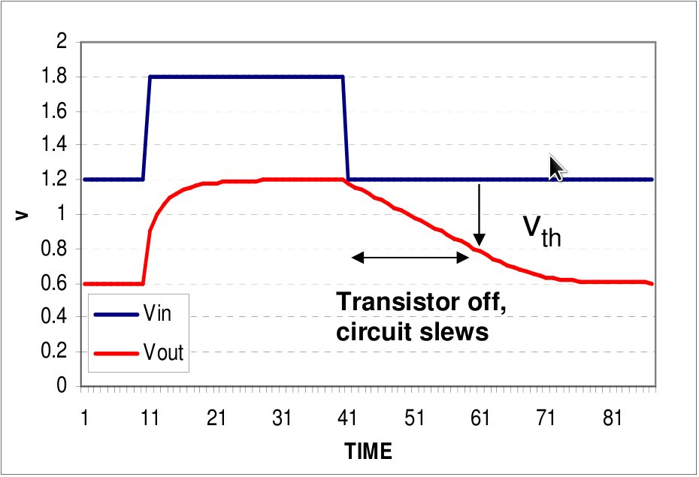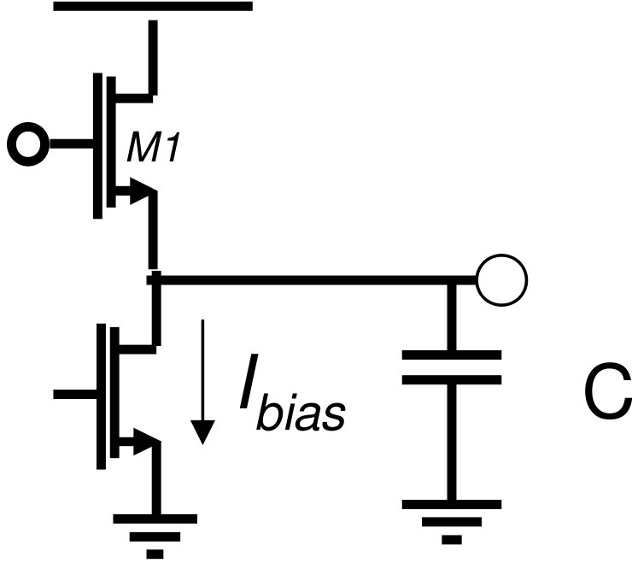
Figure 9: Slew rate illustration Figure 10: Slew rate in an amplifier

What we noticed in our hardware was that the waveform between the output of our input op amp and the decoupling capacitor was much distorted when the input was around 20kHz. We input a sine wave and simply expected a larger sine wave back at the output. What we saw instead was a triangle shaped wave with a funny kink at the tops and bottoms. When we turned the frequency down or decreased the closed loop gain, the phenomenon was still present but to a lesser extent. We realized that the reason we were seeing this effect was that the output capacitance was a rather large .1uF. This load is much more than the LM358 can drive at 20kHz with a 1V swing.

Minimum slew rate to make 20kHz with 1V swing : 2*(1/20kHz) = 100V/us. We were able to fix this problem by purchasing the LM7171, a very high slew rate op amp.

Another problem we ran into was that the method we used for biasing the decoupled input signal lead to a voltage divider which attenuated the signal more than expected. In retrospect, this divider was not necessary.

Software Testing

The majority of the software testing we had to do for our project was testing the sampling rate and the interface with the ADC converter. The first part of this testing was to figure out exactly how fast we could signal the ADC to perform the conversion. We did this by setting the prescalar of the clock and the OCR0A to different values and measuring the interval between successive CONVST signals on the microcontroller. Since the ADC can perform a conversion every 420 ns, we decided to test the CONVST signal using the timer prescalar of 1 and setting OCR0A. According to calculations, this means that the CONVST signal should be triggered every 625 ns. We found that even running at this fast rate we were only signaling the ADC to start a conversion every 7.2 us. We figured that this was due to the time required to enter and exit the ISR.

Clock Scalar | OCR0A | Calculated CONVST Interval | Actual CONVST Interval | Frequency
1 | 10 | 625 ns | 7.2 us | 136.6 kHz
1 | 128 | 8 us | 8.08 us | 123.8 kHz
1 | 255 | 15.94 us | 16.10 us | 62.5 kHz
2 | 10 | 5 us | 7.6 us | 136.6 kHz
2 | 128 | 64 us | 65 us | 15 kHz
2 | 255 | 127.5 us | 128 us | 7.81 kHz
3 | 10 | 40 us | 44 us | 22 kHz
3 | 60 | 240 us | 260 us | 3.8 kHz
Figure 11: Table with expected and actual CONVST intervals
In testing the ADC, we also wanted to make sure that our CONVST signal was not too fast on the ADC. Even though the datasheet assured us that it only took 420 ns to complete a conversion and our CONVST signaling interval was much greater than that time we wanted to make sure that we were acquiring good data at fast sampling rates. We did this by making sure EOC was back up to 1 before CONVST went low again.

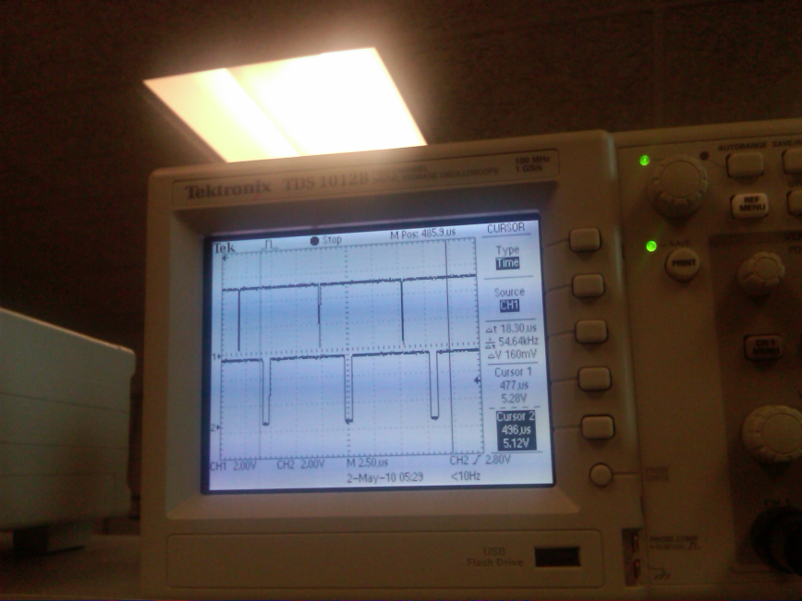
Figure 12: Signal on the top of the screen is CONVST, the signal below is EOC

The final test we did with the ADC included displaying the signal we were sampling on the oscilloscope and looking at the RD signal so we could get some idea of how the signal was being sampled and if the sampling rate was fast enough to get a good representation of the signal.

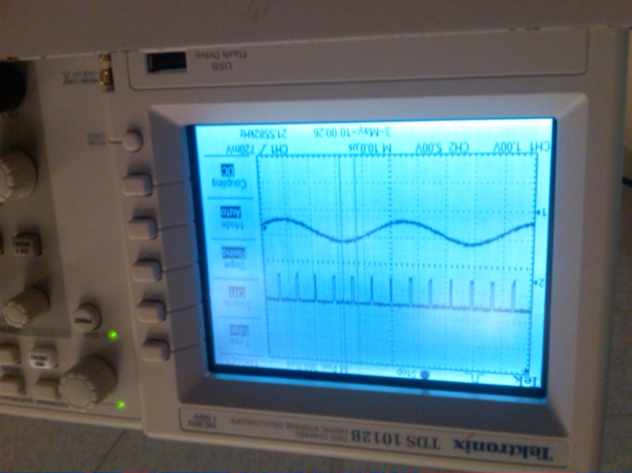
Figure 13: Sampling of a test signal

Results

Safety
During construction of our circuit boards, we took many measures to ensure our safety as well as the safety of others around us. We wore goggles when soldering and made sure that the iron was at an appropriate temperature. After soldering, we always turned off the iron.
Our end product is very safe. Since we are not using any high voltage systems (the highest voltage is 12 V used to power the microcontroller), our oscilloscope does not present any opportunities for electric shock. We took care in our wiring and tried to minimize the amount of exposed copper so that no accidental shorts would happen. The only factor that presents a minimal safety concern is the somewhat sharp edges on the circuit boards. However, if a user is attentive and careful, the edges should not present any safety risk.

Usability
Our project does have constraints on its usability. The frequency of a signal, as well as what it looks like can be easily obtained from the oscilloscope. However, our project has a limited input range from 0 V to 2.5 V. Any signal that has an amplitude larger than this will damage the ADC. We could rectify this problem by creating a better level shifter circuit to control the input signal. Furthermore, a user currently cannot an exact amplitude reading from our current design. Finally, we need to label the push buttons so that a user is aware of approximately what time per division range he or she is selecting.

Accuracy
In general, our oscilloscope is able to accurately represent a signal onto the video screen. We measured the accuracy by inputting a signal with a known frequency into the oscilloscope and estimated how many time divisions the signal occupies on the screen noting that this method in itself creates error. We then calculated the frequency of the signal based on how many time divisions one cycle occupies and compare it back to the known frequency of the function. We found that in general the higher frequencies resulted in a higher percentage of error.
Our Measured Frequency | Function Generator Frequency | Percent Error
10.5 Hz | 10 Hz | 4.80%
95.7 Hz | 100 Hz | 4.50%
1.66 kHz | 1.5 kHz | 9.6%
4.76 kHz | 5 kHz | 5.04%
22.4 kHz | 20 kHz | 10.70%
Figure 14: Table showing accuracy of oscilloscope measurements

Conclusion
Our project met our expectation as a functional oscilloscope. However, we did not meet our expectations in the features that we were going to add to the oscilloscope. We are able to display good resolution waveforms between frequencies ranging from 1 Hz to 2 kHz. By pushing one of five push buttons, the oscilloscope will change its time per division setting. This functionality worked flawlessly as the user can either analyze a small section of a waveform or increase the time span to analyze a longer portion of a waveform. Unfortunately, our level shifter and attenuator circuit did not work too well. The attenuator attenuated our signal too much, while the level shifter only shifted the DC point by about 100 mV. Furthermore, we did not have enough time to implement a spectrum analyzer, as debugging took much more time than expected.
Our greatest challenge was to figure out how the data was going to be transferred between the two microcontrollers. We tried various different approaches when working on this. We started by using a handshake protocol between the two boards, but found that it was slow and unreliable. We got the idea of using an external interrupt on the acquisition board from the method of communication with the ADC. We found that it was the quickest way and did not require two handshake signals, just the one external interrupt signal.
Our project required a tremendous amount of wiring and we definitely could have organized this much better. Optimizing where each circuit would go and shortening the lengths of the wires would have made ourproject more neat and presentable. To improve usability, we could have labeled the push buttons so that the user would know which button corresponded to which time per division. Also, we could have implemented some cursors to display on the TV screen. This would make measuring the time per divisions much more accurate compared to just eye-balling them on the screen.
The analog front end could have been implemented much better if we had more time. The original plan was to use a bipolar supply but this seemed to cause excess heat in the op amps. This would have increased our input swing and give us the ability to shift the signal down as well as up. Also, the biasing resistors could have been increased to reduce attenuation without having to have large gain into the
capacitive load.

Intellectual Property Considerations
Since an oscilloscope was built as a final project in a previous year for ECE 4760, we looked at how the other group had done their project (http://www.nbb.cornell.edu/neurobio/land/PROJECTS/VideoScope/). We noticed that they used a black and white TV to display the waveform, so we decided to do the same. We also looked at Yi Yao's website (http://yyao.ca/projects/oscilloscope/) for ideas. Our logical structure is partly based on Yi Yao's block diagram. We did not use any of the code that Yi Yao provided. Furthermore, we looked at the instructions for the oscilloscope lab done in previous years for ECE 4760 (http://instruct1.cit.cornell.edu/courses/ee476/labs/s2007/lab4.html). However, we did not get any ideas from this; for the most part, our design was completely independent of what was done before. We do not believe that there are patent opportunities for our project since oscilloscopes are widely available.

Ethical and legal considerations
During the design of this project, we strived to follow the IEEE Code of Ethics. Our project does not present any safety or health concerns to the public. While constructing the circuits, we were very careful with the soldering irons so that it did not burn us nor anyone around us. Our results are stated honestly and truthfully; we did not manipulate any of our data. While working on the project, we tried to maintain a safe and supportive environment. We treated our peers with respect and took everybody's suggestions and criticisms seriously. We also helped other groups by providing items that they needed. Our oscilloscope is meant to provide students with a better understanding of how electronics work. It is an incredibly useful tool for debugging circuits as well as measuring voltages. Through our project, we hope that there can be an improved understanding of technology. For us, this is definately true, as we have learned so much after completing this assignment. We do not intend to sell our product in the market so there are no legal considerations. If we did, then product safety must be considered.

Appendices

A. Datasheets
LM 7171 Op Amp: http://www.national.com/ds/LM/LM7171.pdf
AD 7825 Analog to Digital Converter: http://www.analog.com/static/imported-files/data_sheets/AD7822_7825_7829.pdf
Atmel MEGA644: http://instruct1.cit.cornell.edu/courses/ee476/AtmelStuff/mega644full.pdf

B. Budget
Item | Number | Supplier | Cost
Custom PC Board | 2 | 4760 Lab | $ 8.00
Mega644 | 2 | 4760 Lab | $ 16.00
B/W TV | 1 | 4760 Lab | $ 1.00
6 Inch Solder Board | 3 | 4760 Lab | $ 7.50
2 Inch Solder board | 2 | 4760 Lab | $ 2.00
Power Supply | 2 | 4760 Lab | $ 10.00
DIP socket | 2 | 4760 Lab | $ 1.00
Pin Headers | 40 | 4760 Lab | $ 2.00
AD7825 | 1 | Analog Devices | $ -
1 Pin Jumper Cables | 3 | 4760 Lab | $ 4.00
Alligator Clips | 3 | 4760 Lab | $ -
SOIC Carrier Board | 1 | 4760 Lab | $ 1.00
Op Amps (Not LM358) | 2 | Digikey - National Semiconductor | $ 5.66
Resistors/Capacitors/Push Buttons | Many | 4760 Lab | $ -
 | Total Cost |  | $ 58.16
Figure 15: Table with project budget

C. Commented Code Listing

Scope_calc.c
Scope_video.c

D. Schematic
Oscilloscope Schematic

E. Division of Labor
Most of the work on this project was done by all three group members working together. All three members were involved in the physical construction of the project as well as the testing and debugging. Luke and Richard did focus more on the analog circuit design of the level shifter and amplifiers while Emily worked more on the code, particularly on scope_calc.c and interfacing with the ADC.

F. Special Thanks
We would like to thank Bruce Land, the course instructor, for providing the lab space and other materials we needed for the project along with much guidance. We would also like to thank TAs Yuchen Zhang and Jeff Melville for helping us in lab and helping us out as we got stuck along the way. Also, Analog Devices for providing samples of the AD7825 we used in our project.

